**PRACTICE**

**1. Install chocolatey software on windows.**

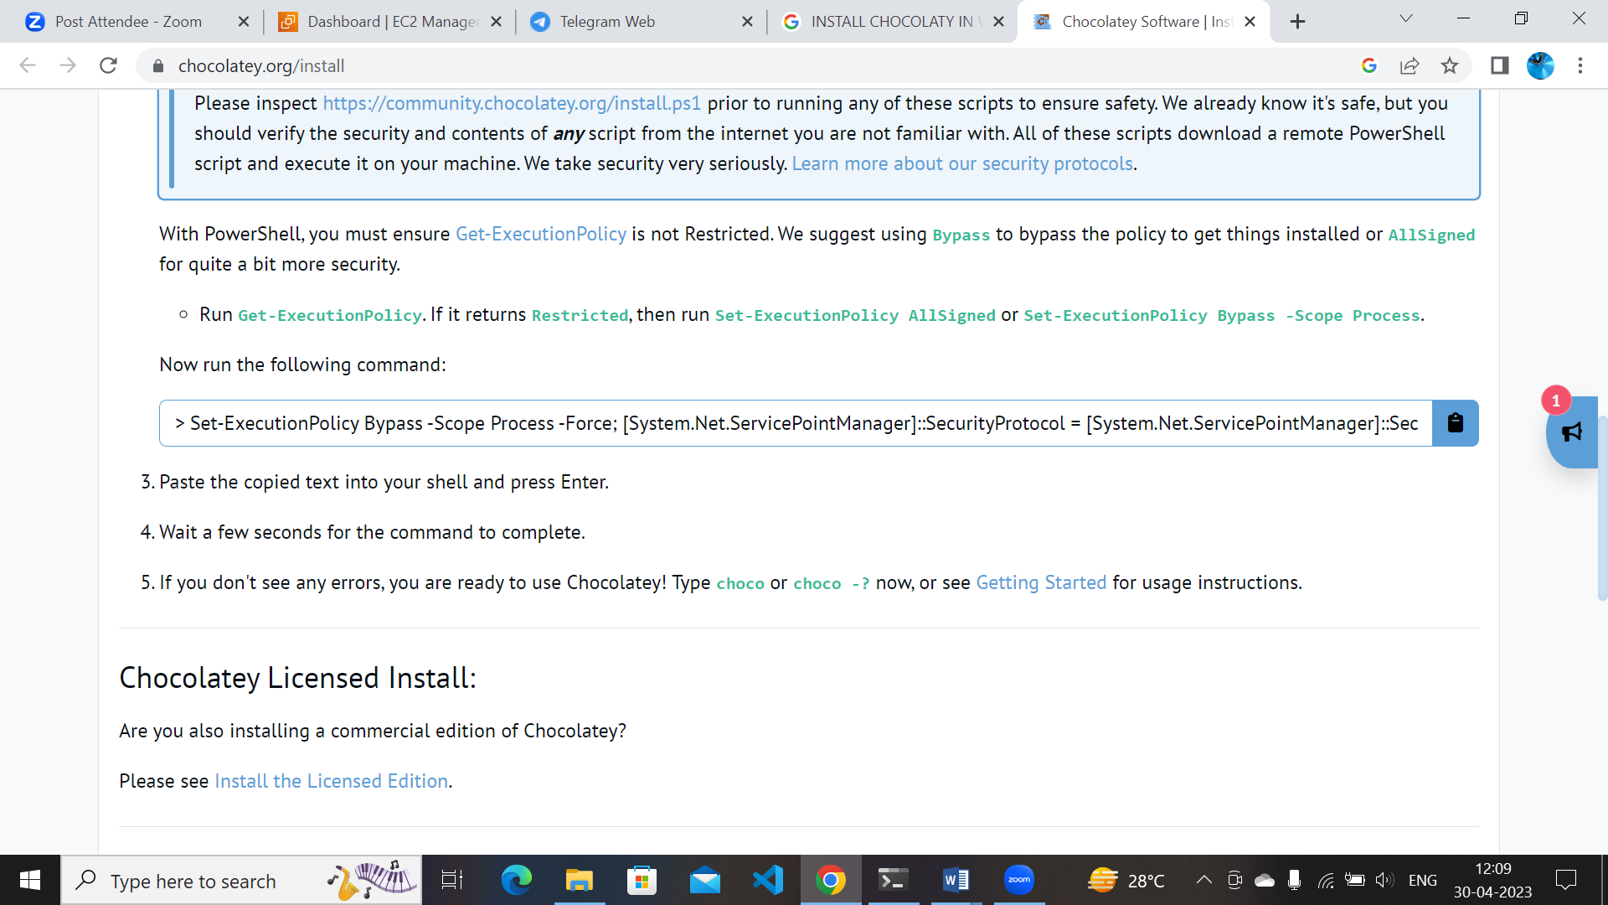

* Search google in how install chocolatey copy the path in
* Open terminal as administrator and paste in the terminal /
* Press enter after installed search choco -–version in terminal
* 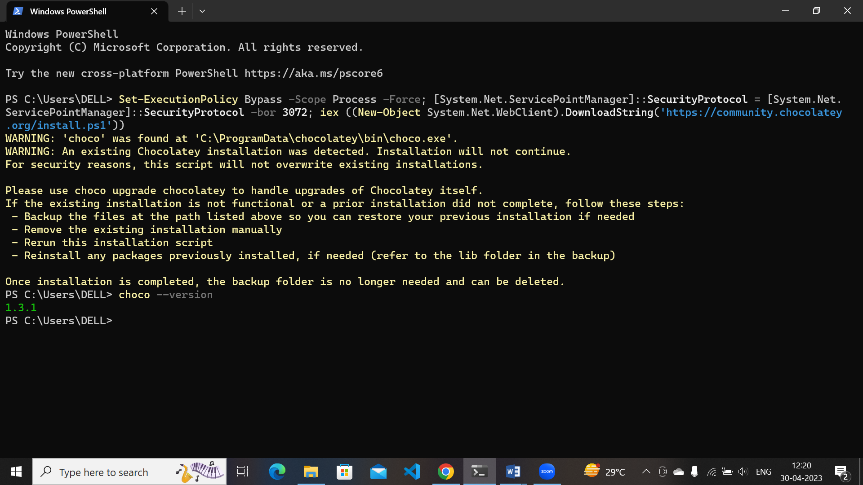

**Choco installed in pc**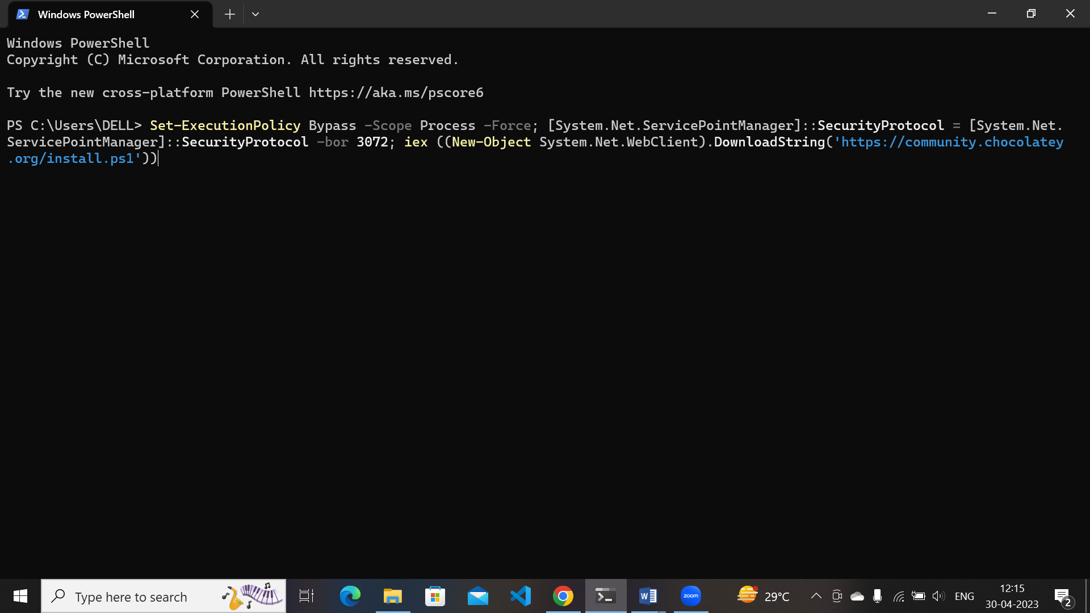

**2)** **Install required softwares using chocolatey.**

**GItbash :** **choco install git.install**

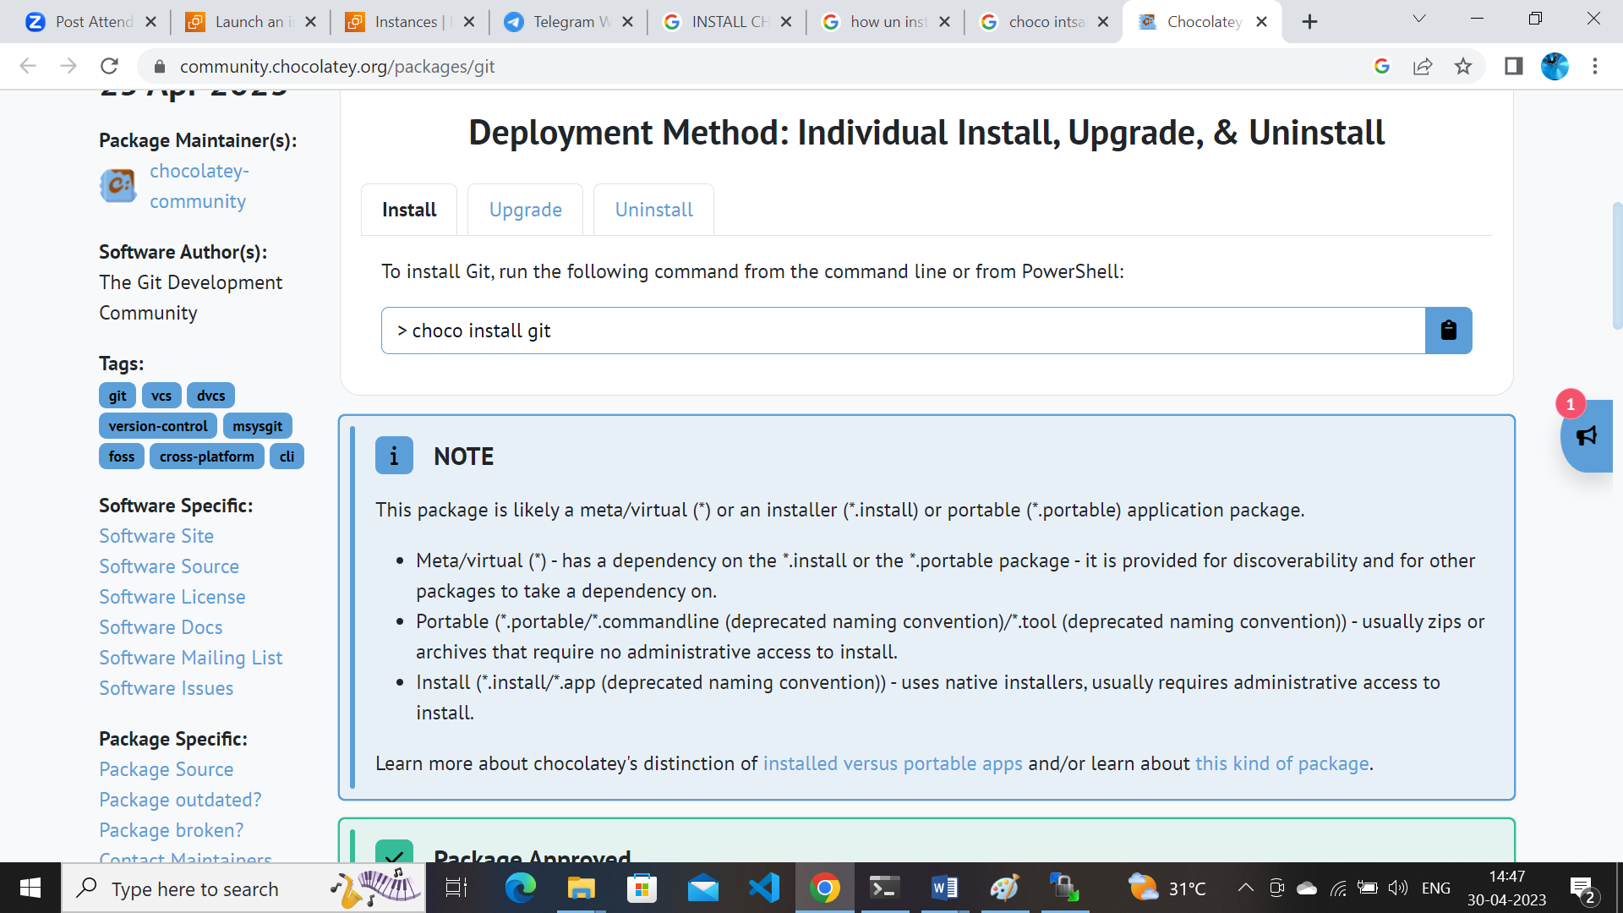

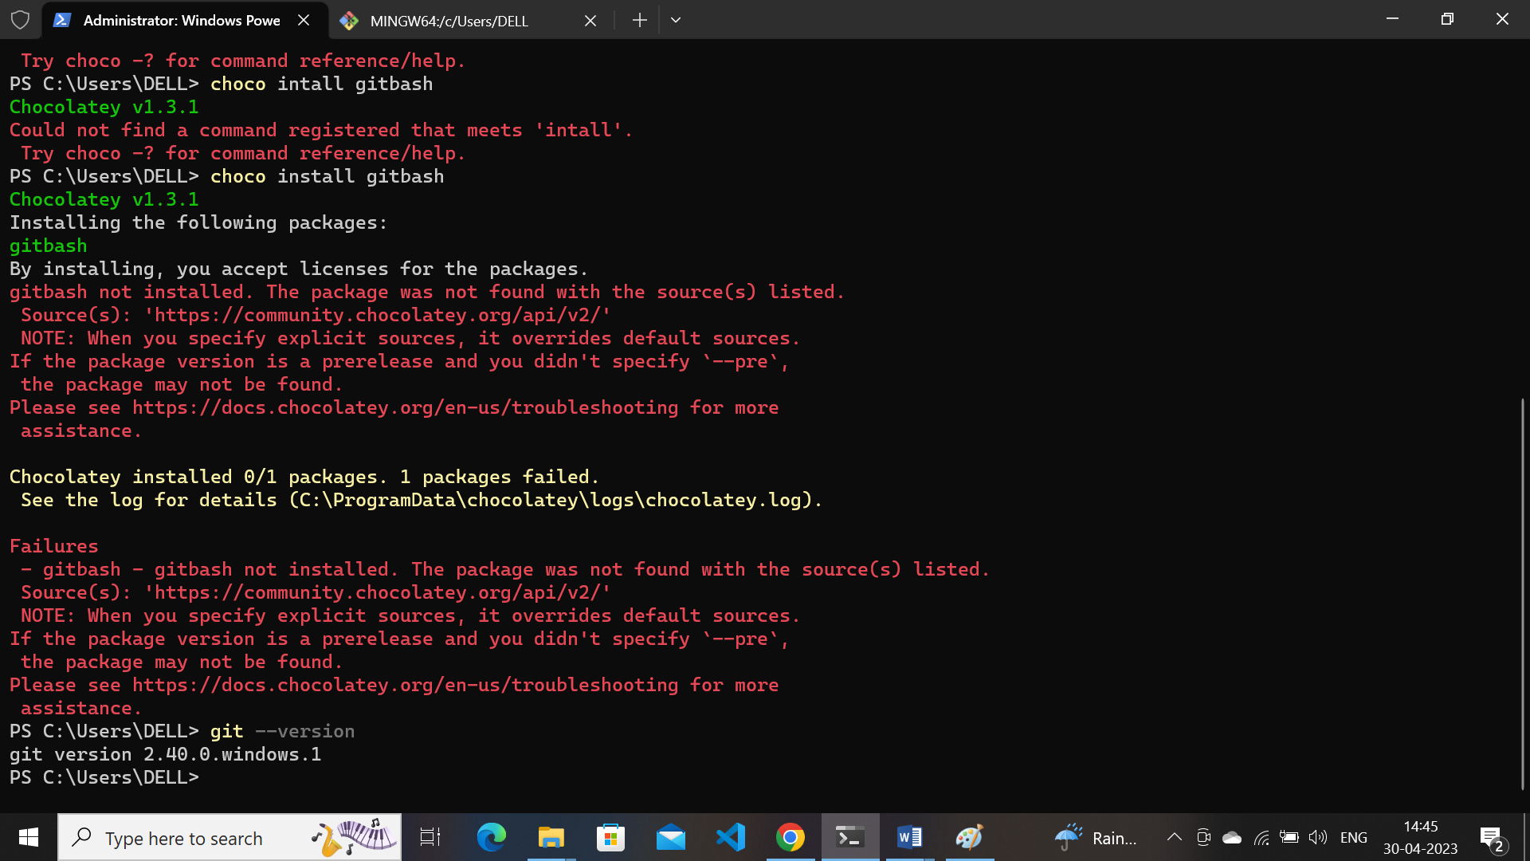

**Winscp:** **choco install winscp**

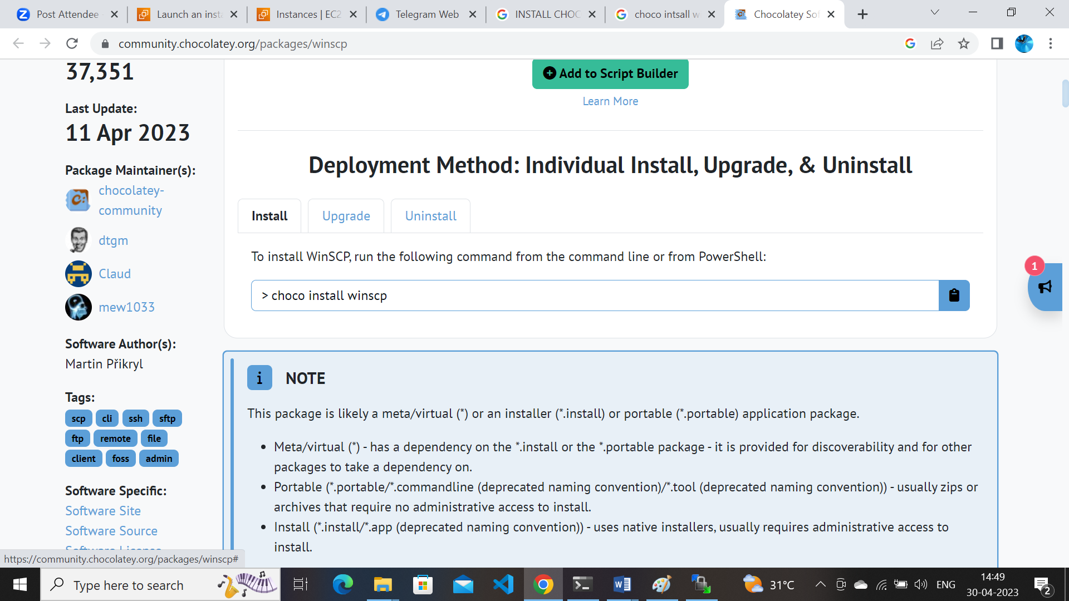

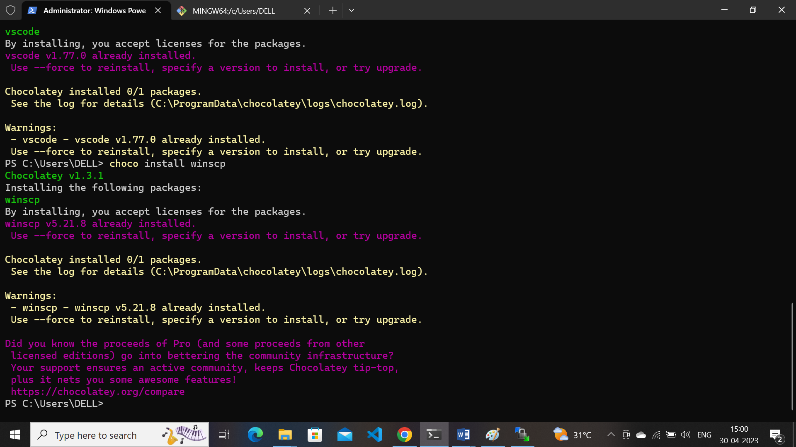

**Notepadplusplus :** **choco install notepadplusplus**

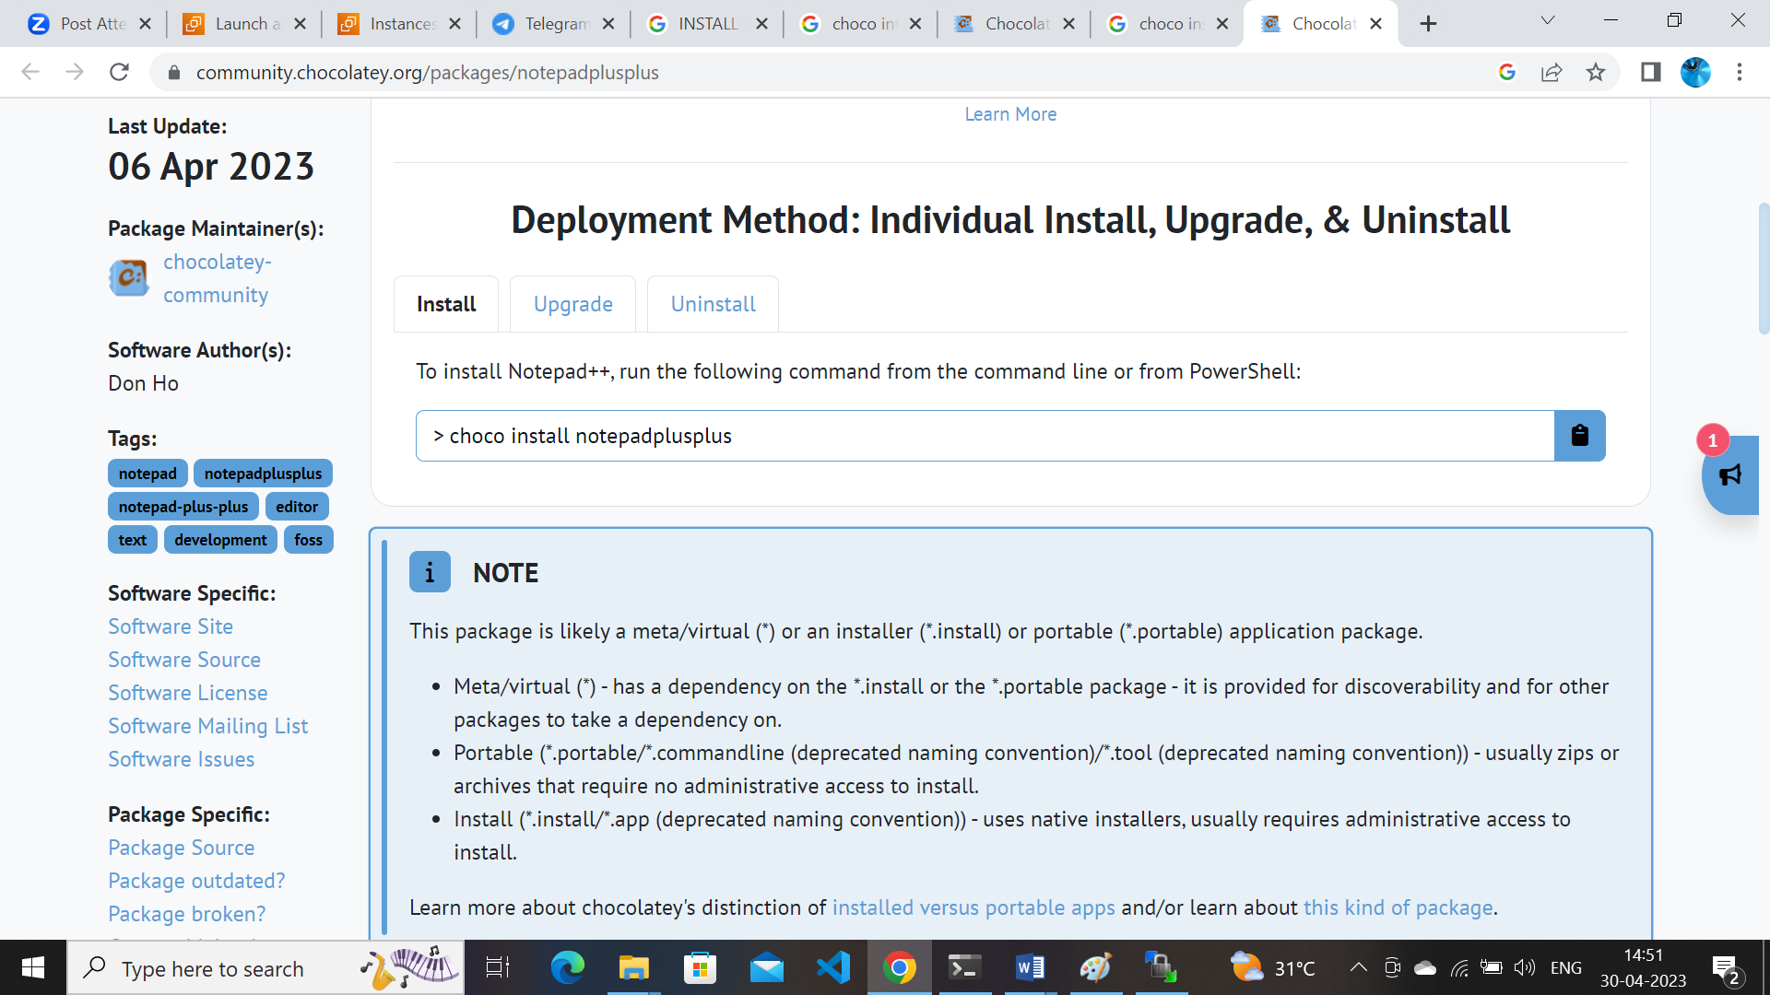

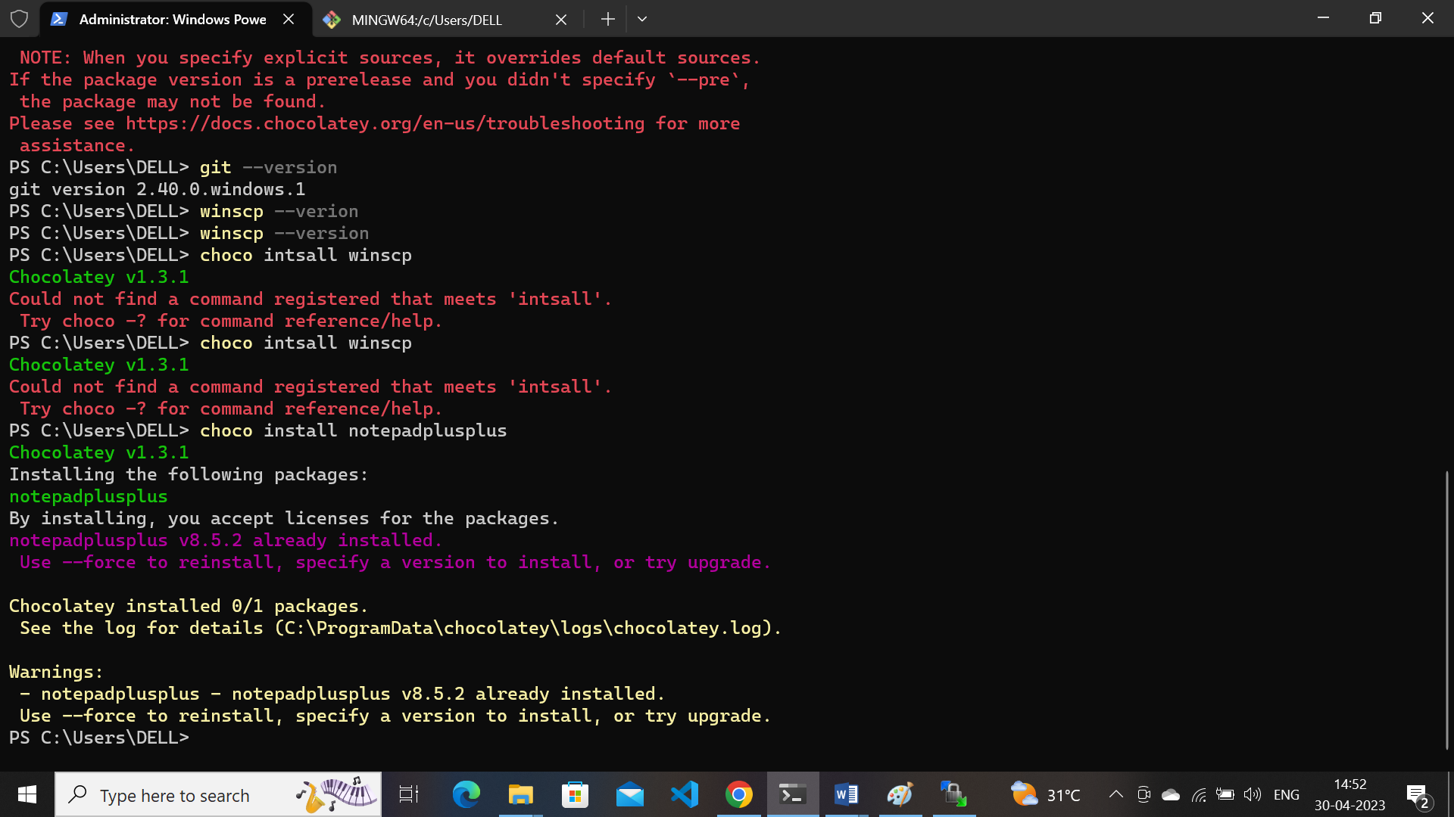

**Vscode : choco install vscode**

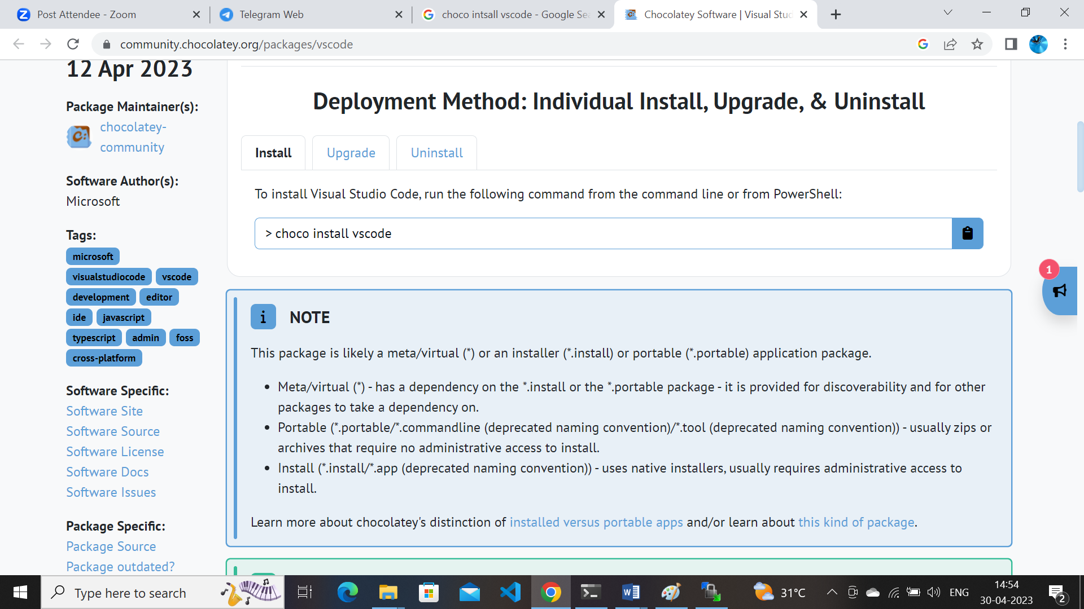

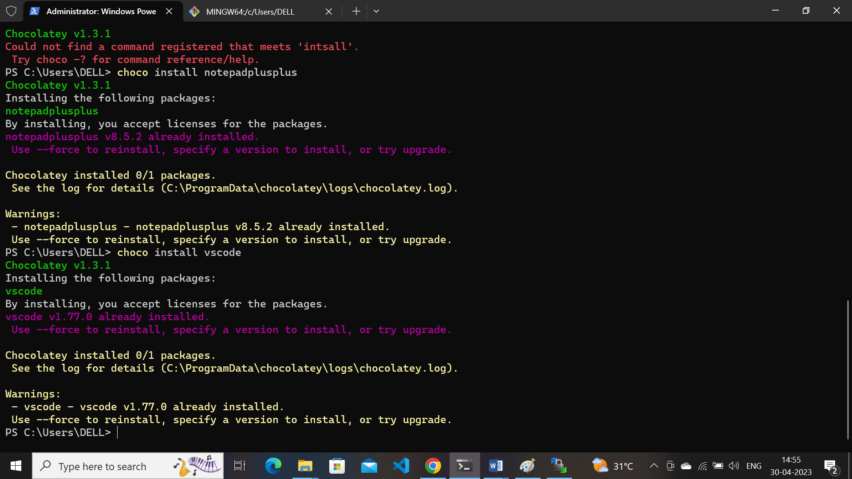

**Putty :** **choco install putty**

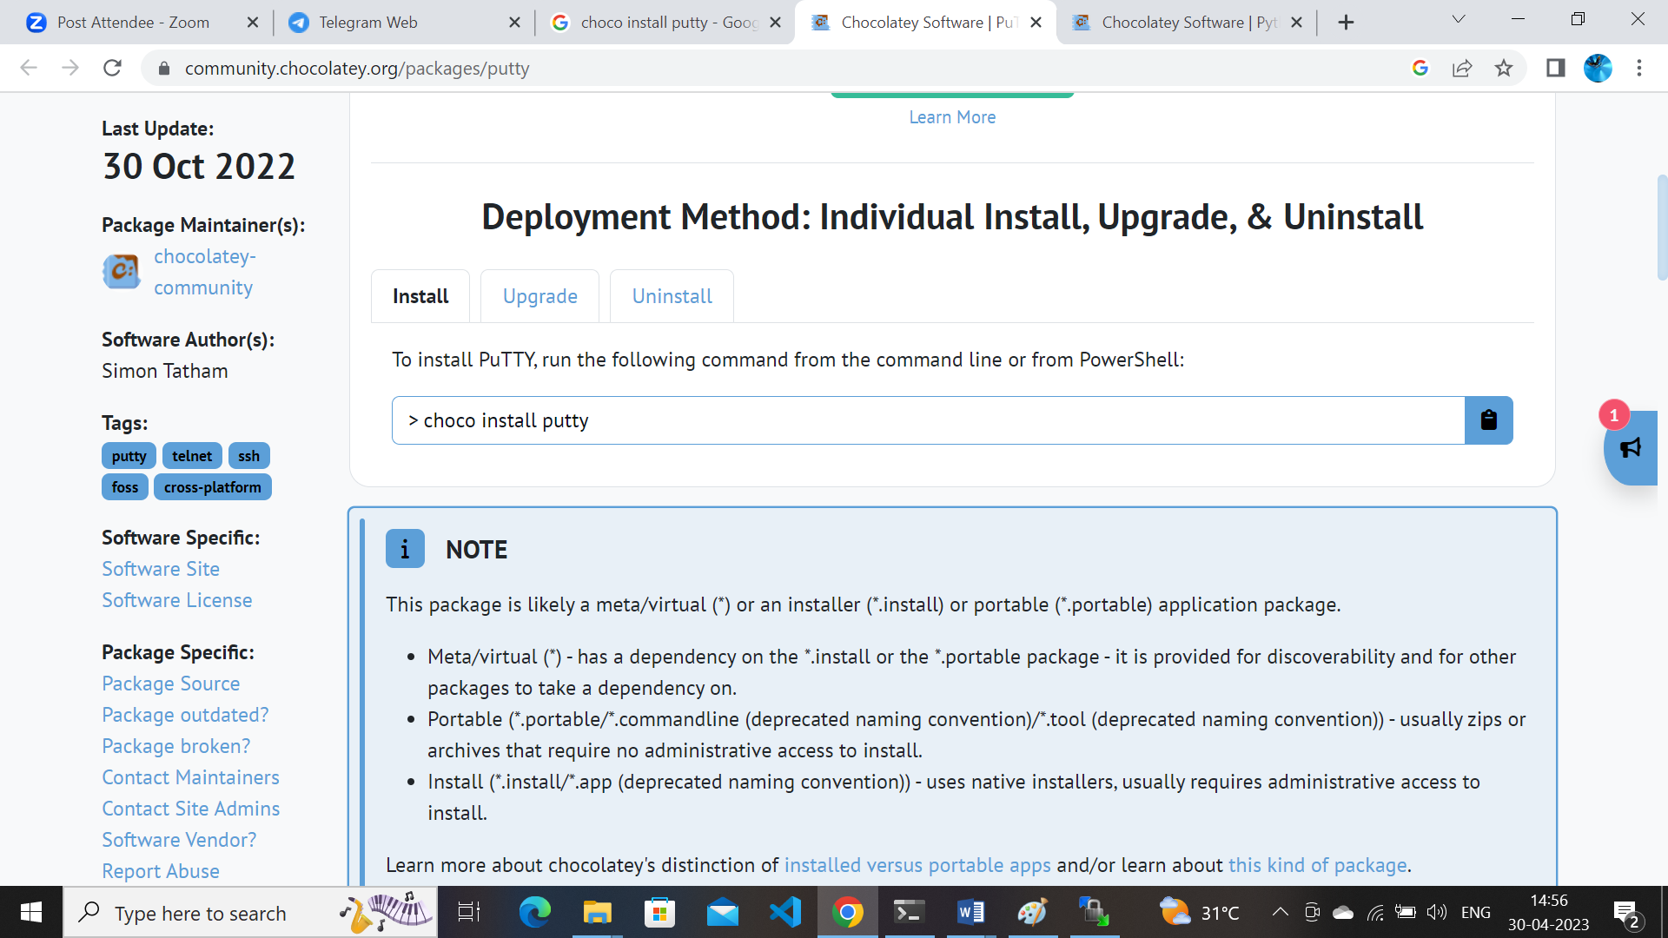

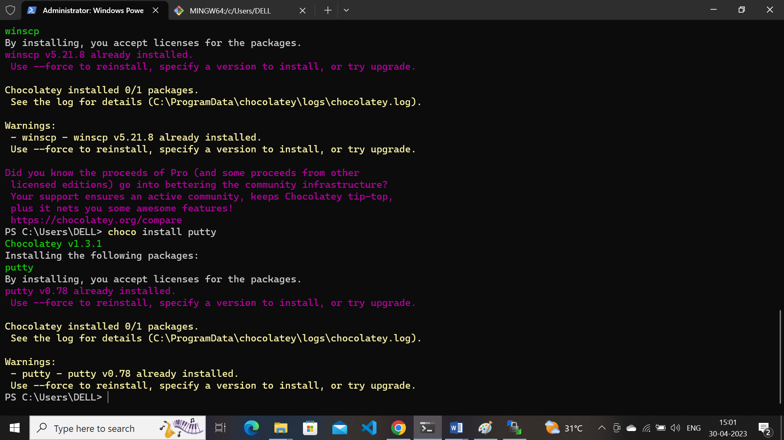

**MobaXterm :** choco install mobaxterm

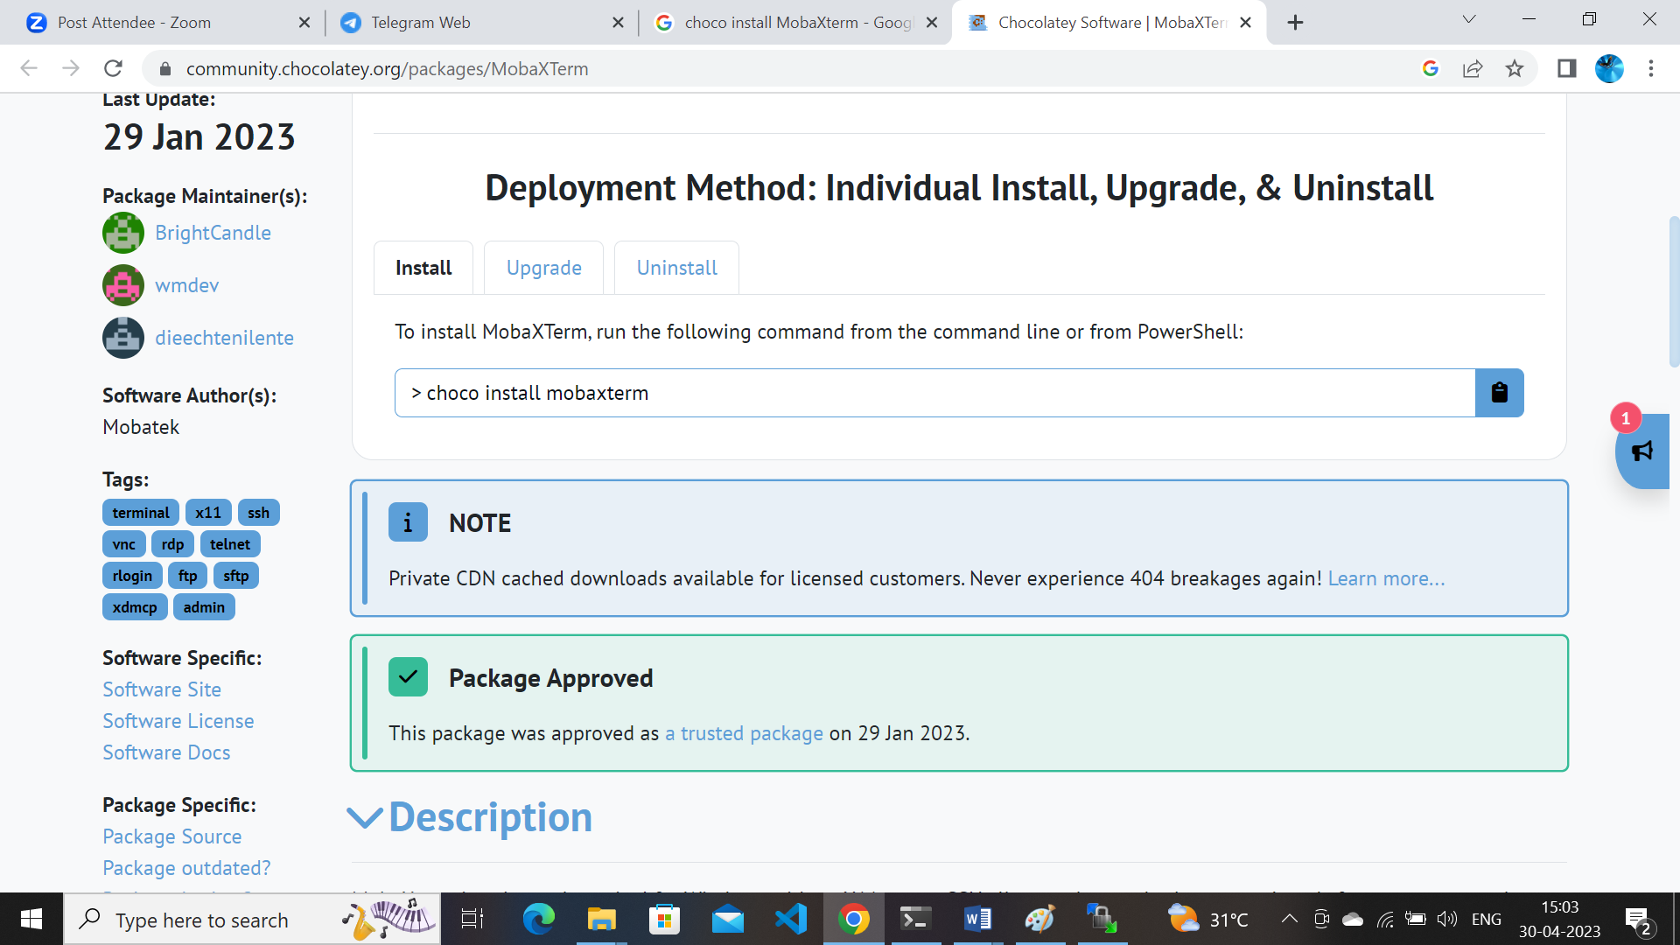

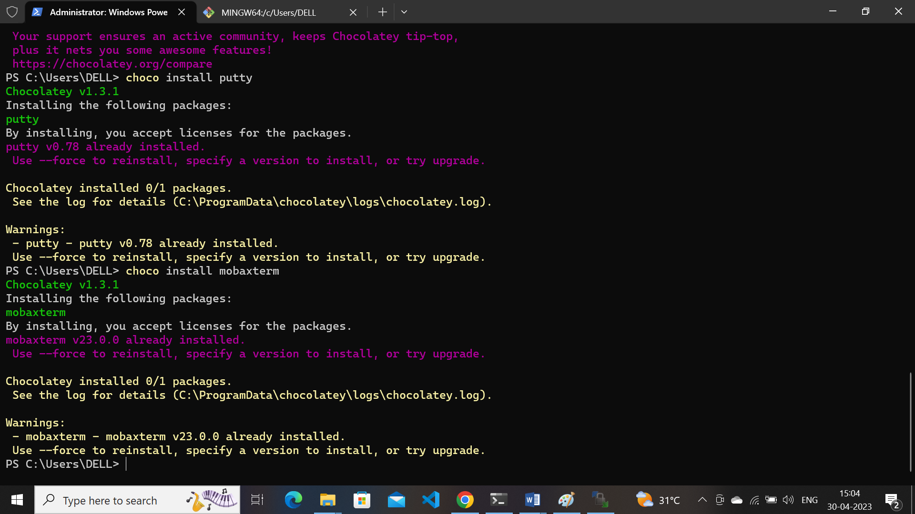

**BeyondCompare : choco install beyondcompare**

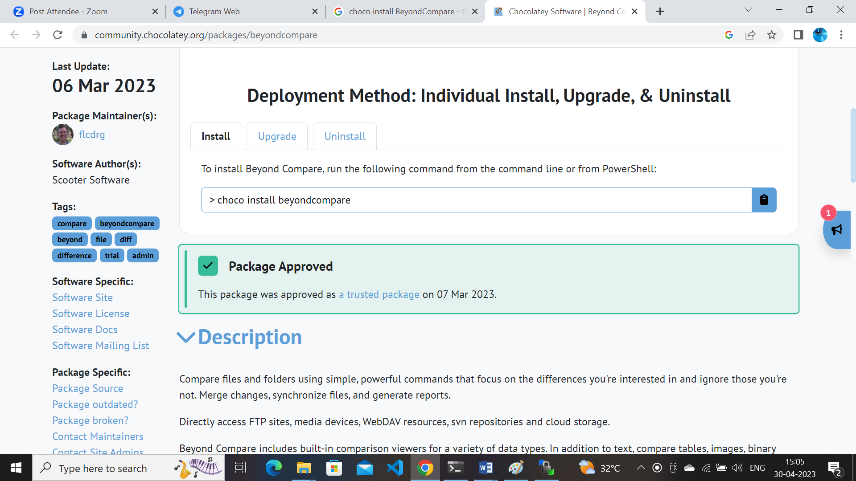

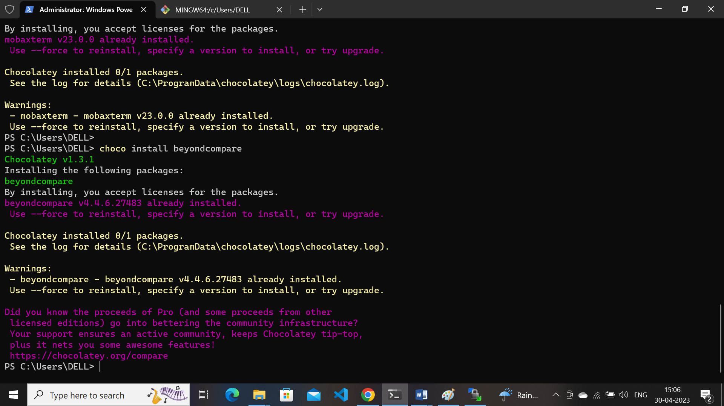

**3). Launching an EC2/VM in azure and aws. Connect using ssh through Powershell/Git Bash/Terminal/MobaXterm.**

* Create a cloud account in **AWS** with credentials search in google
* Login in to aws console
* Select launch instance in the link as shown in picture

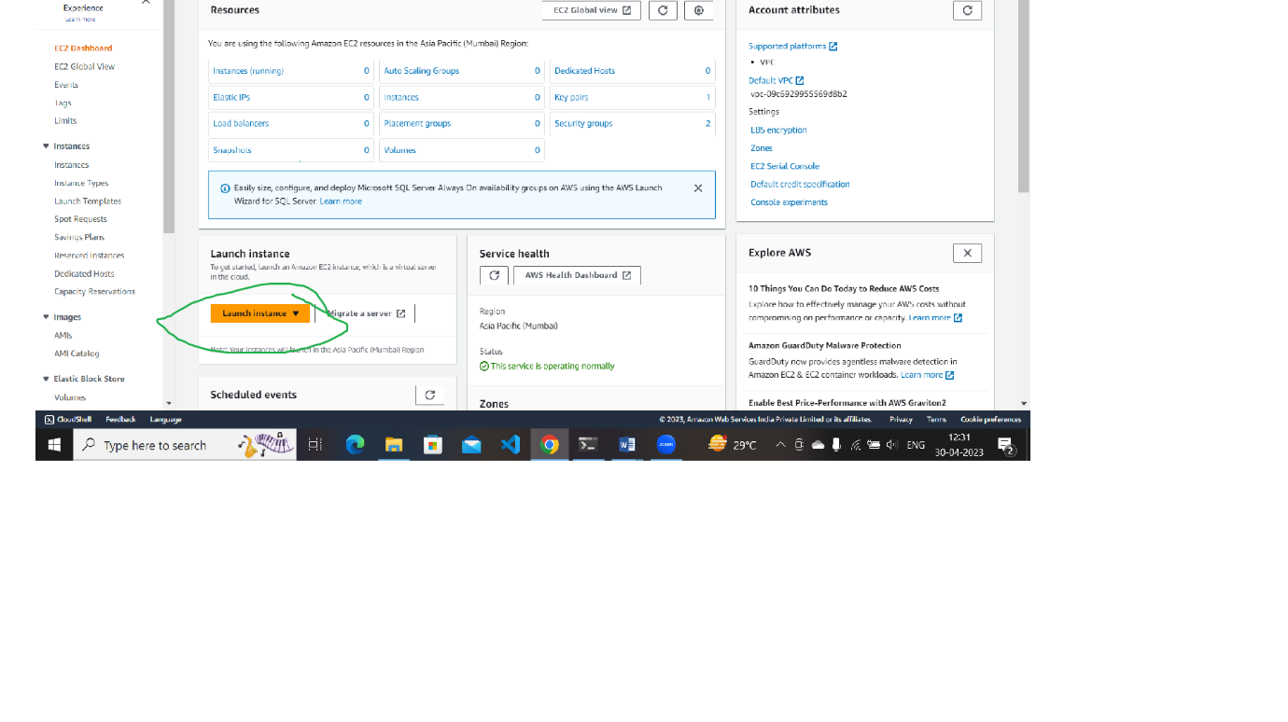

* **Name ---** Give the name for instance /VM
* **Application and OS Images (Amazon Machine Image)---**select linux machine ubuntu / amazon linux /macos/ redhat etc….
* **Instance type ----**select instance type **t2.micro etc**….which is required as per requirement
* **Keypair—**slect create new keypair / give name to key par and select rsa. And .pem file as per the requirement

Select key pair which is created

* **Network settings-**   
  Create security group and /   
  Select existing security group

Select as per requirement in security group and inbound rules in settings

* **Configure storage-**as per requirement storage class selected
* **Advanced details-** to write shell script while creating vm only used advanced details

* Select create instance as picture

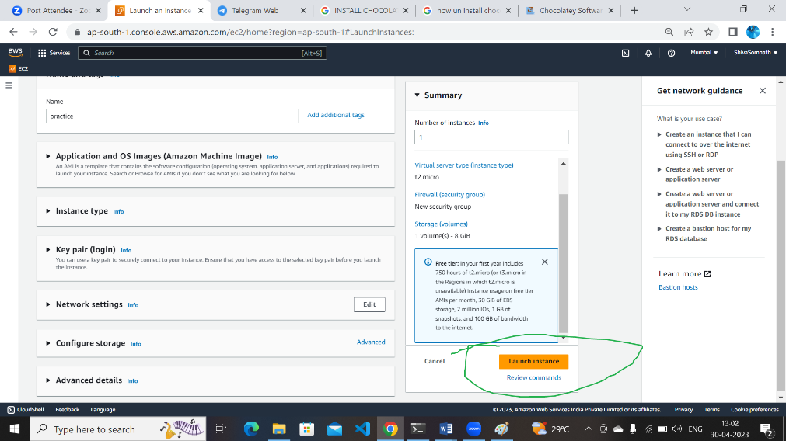

* Instance created now see in home path of console ec2 mission Amazon Elastic Compute Cloud

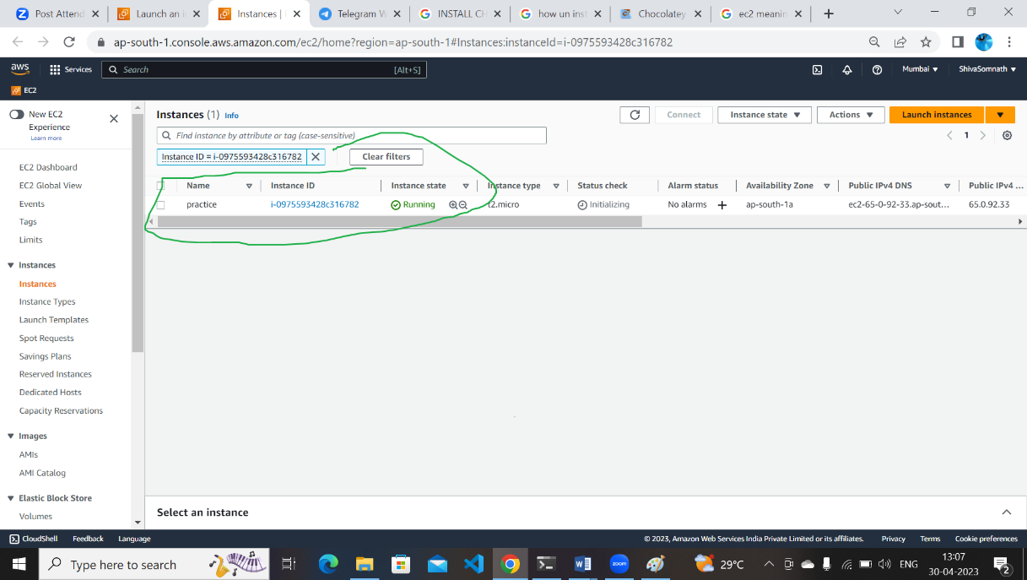

* 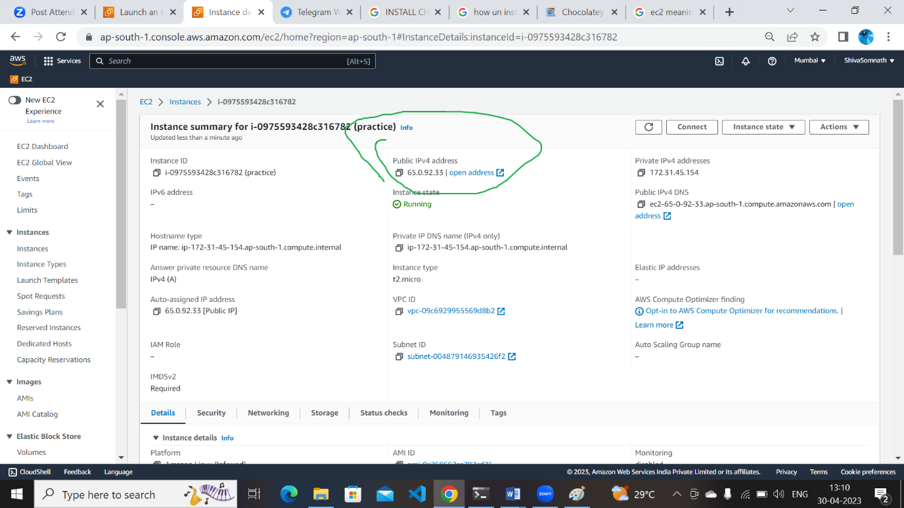
* **Connecting ec2**
* **Powershell**

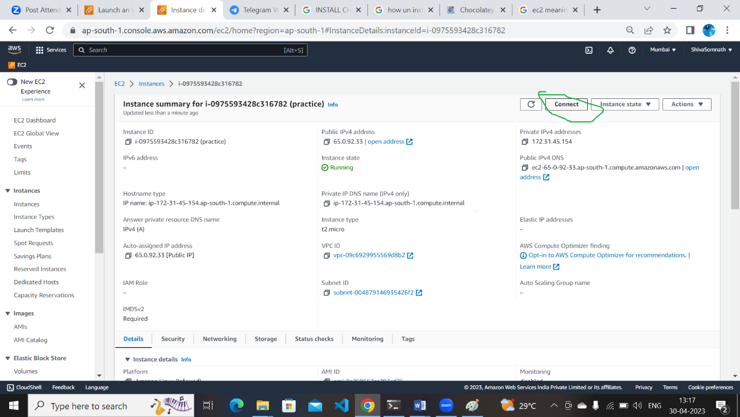

* 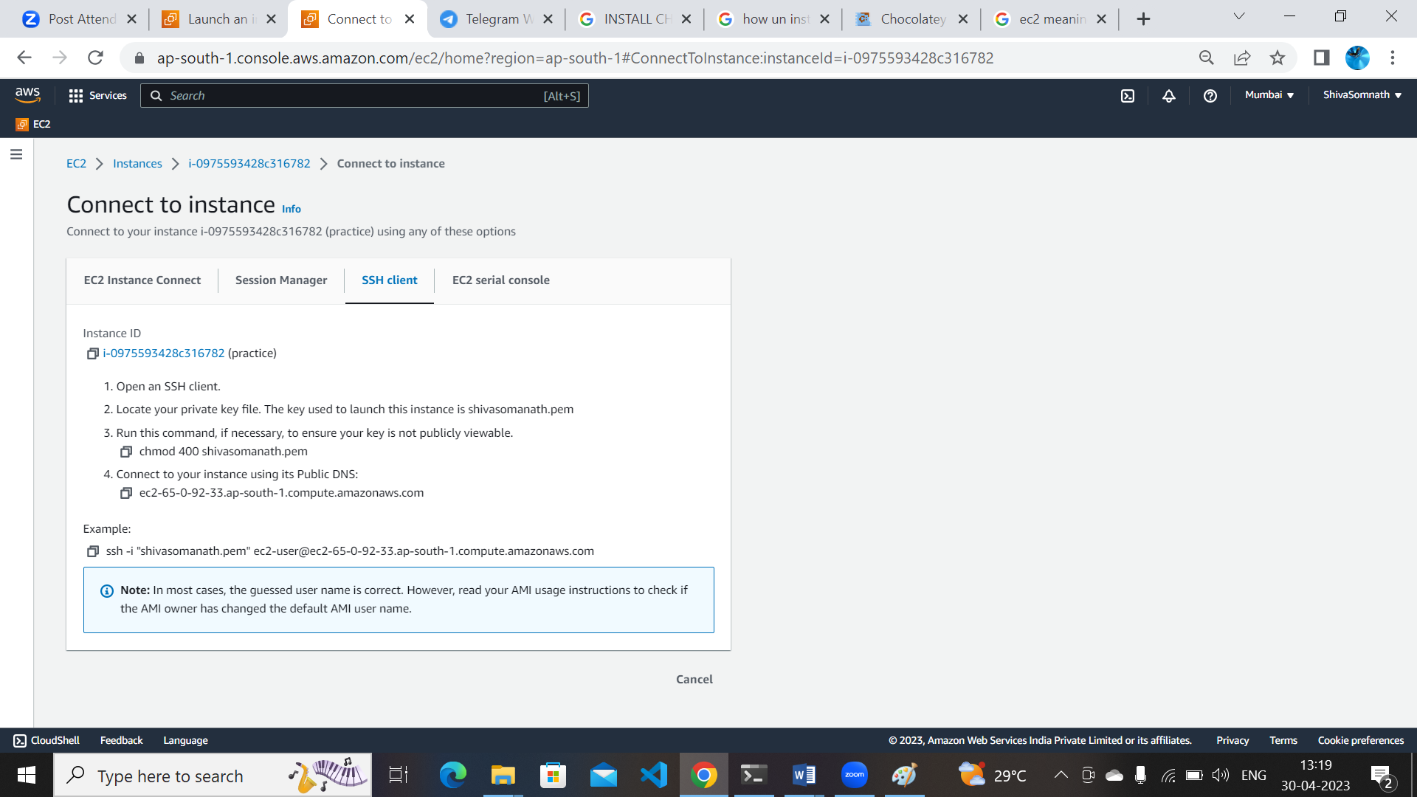
* select example form copy the path and paste in the poweshell /gitbash
* **powershell**
* 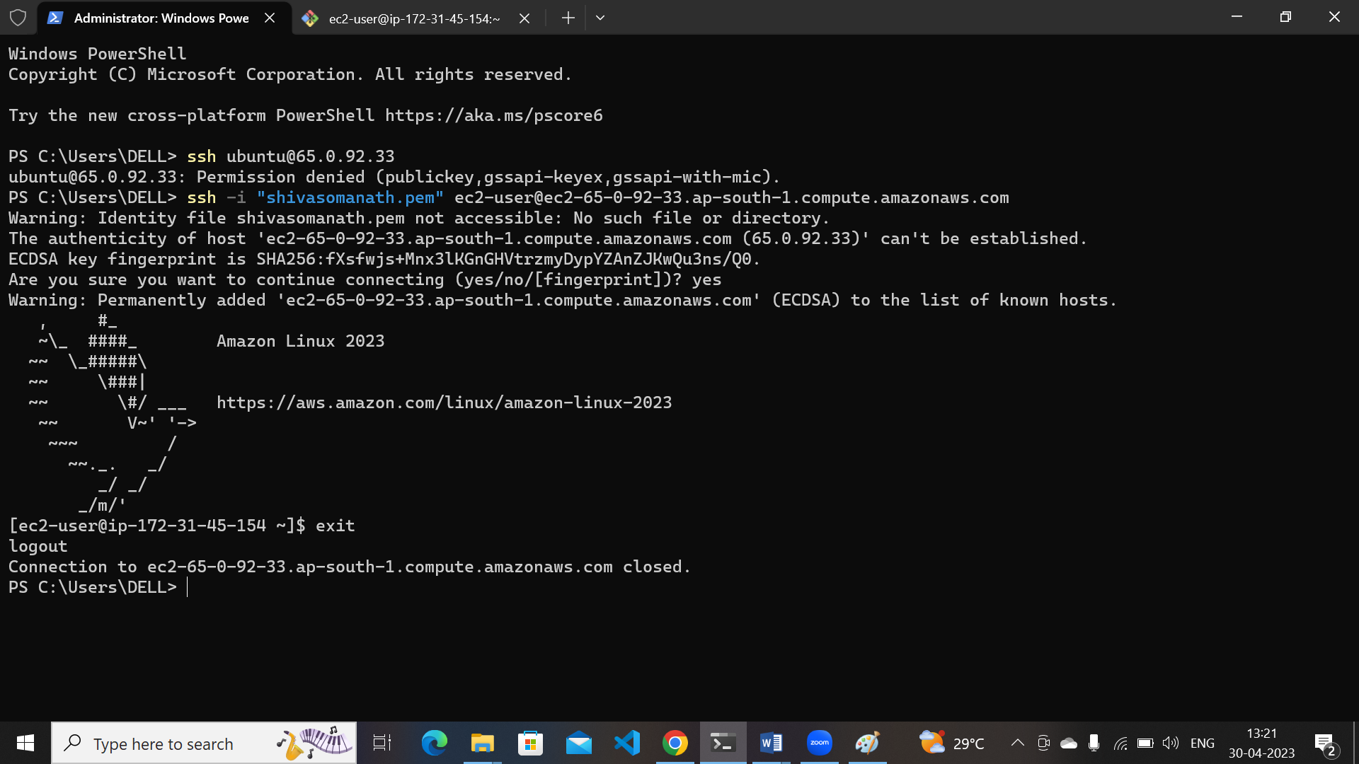
* **gitbash**
* 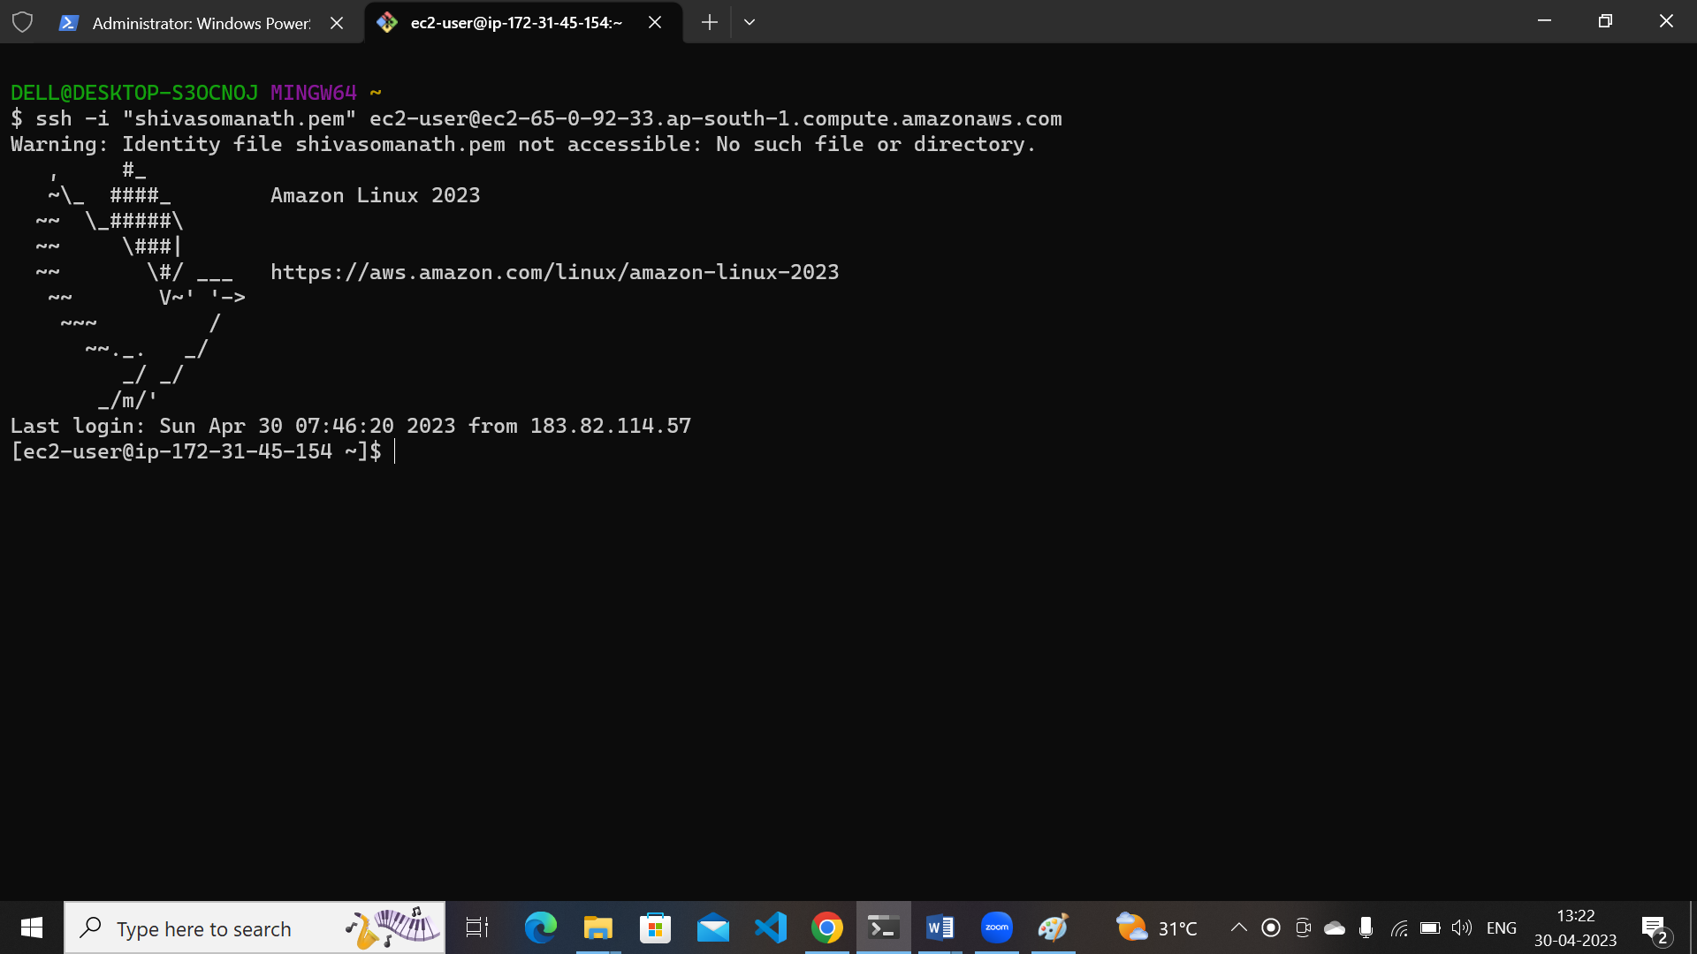

**4)**  **Create a Security Group/NSG in AWS/Azure and assign 22,80 and 443 ports.**

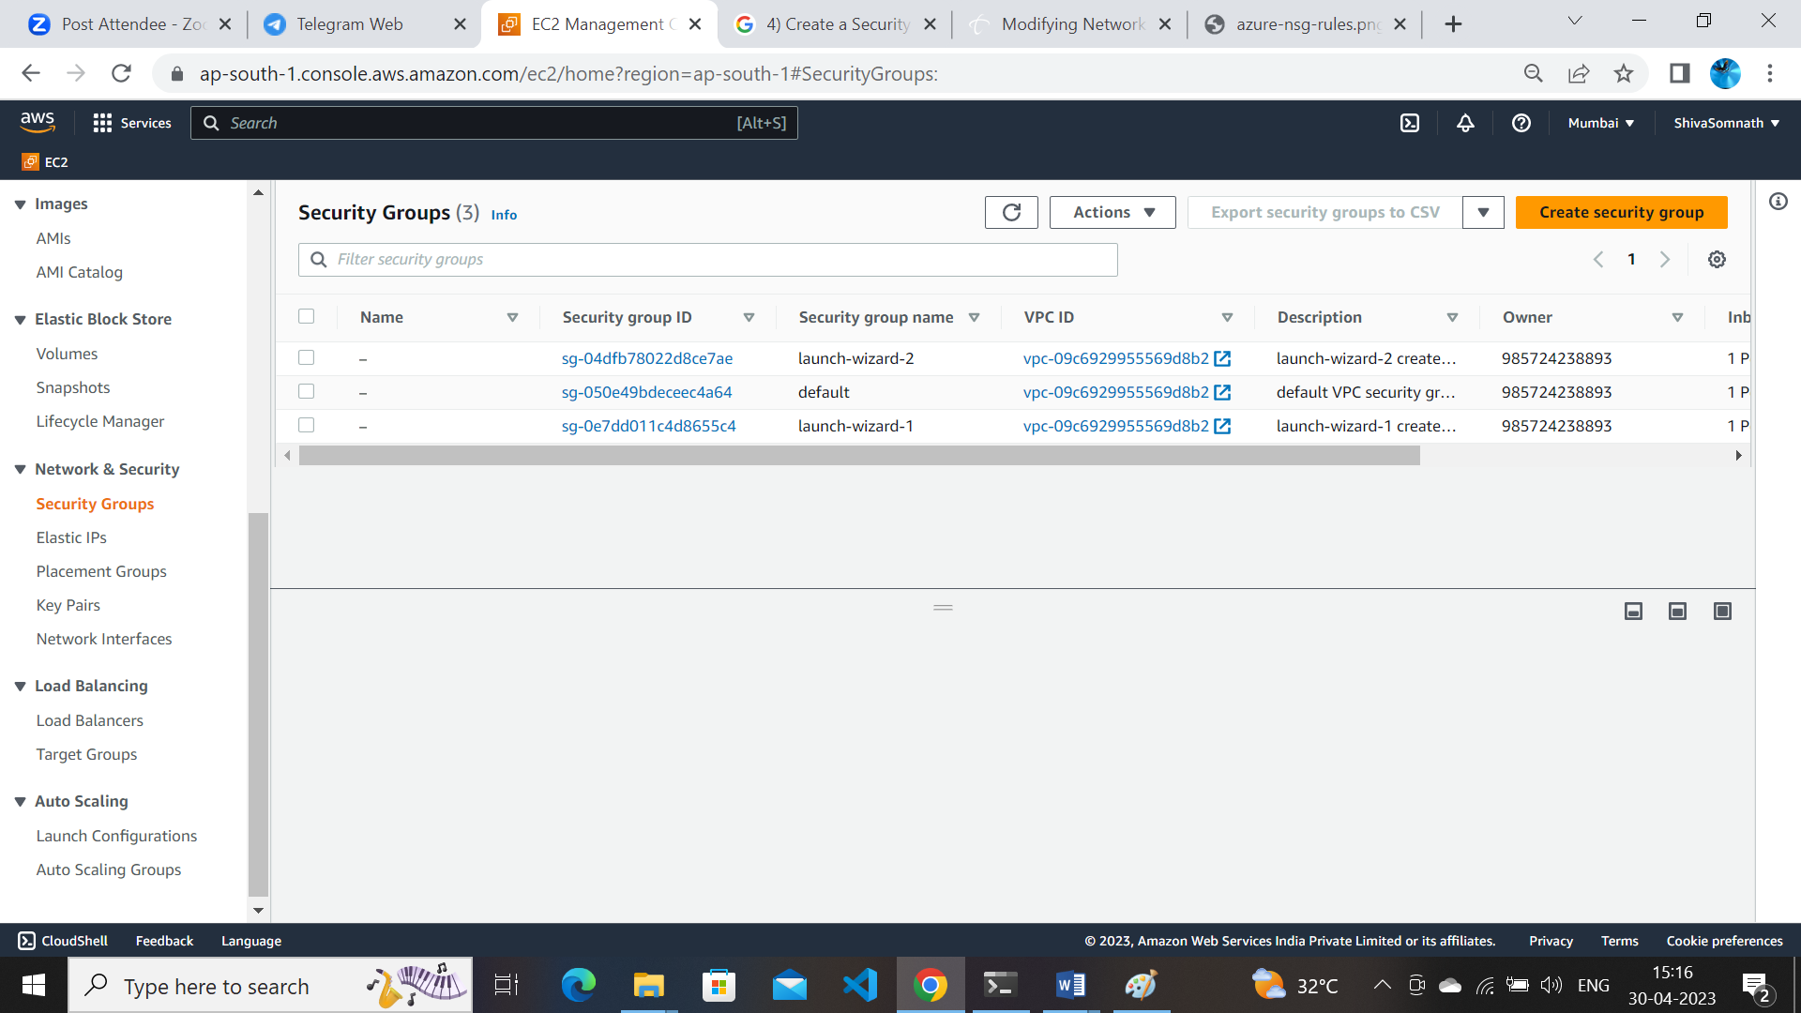

* Select create security group
* Mentioned security group name and description and edit inbound rules
* **Security group created**
* 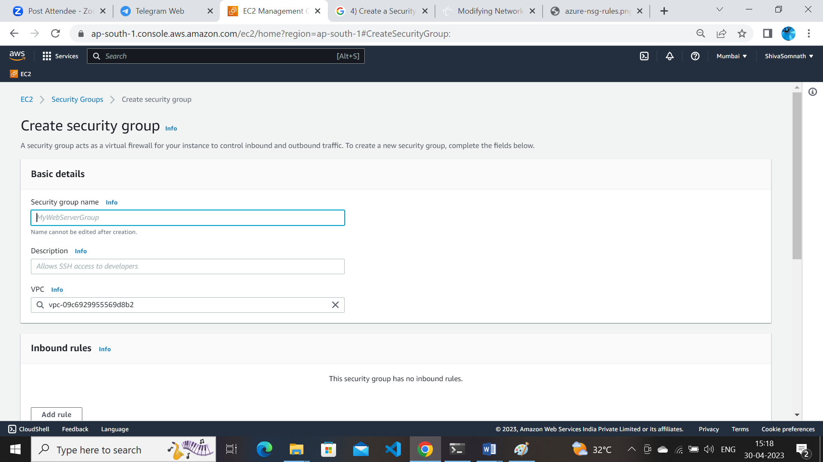
* **Save rules**
* 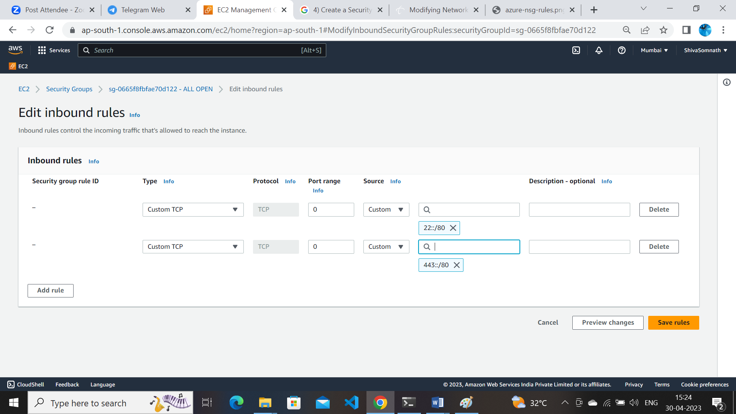

**5)** **Create a keypair in AWS.**

* Open AWS console /// and EC2 dashboard//
* **Select keypairs**
* 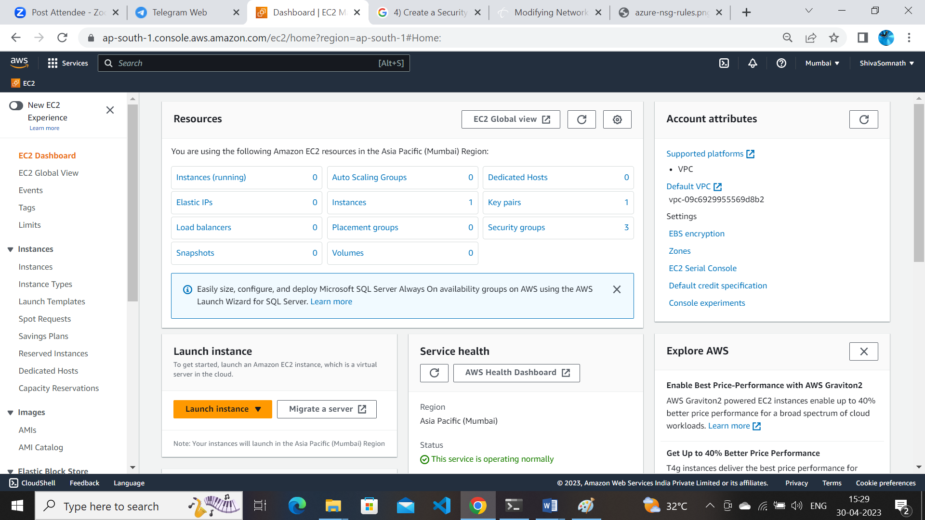

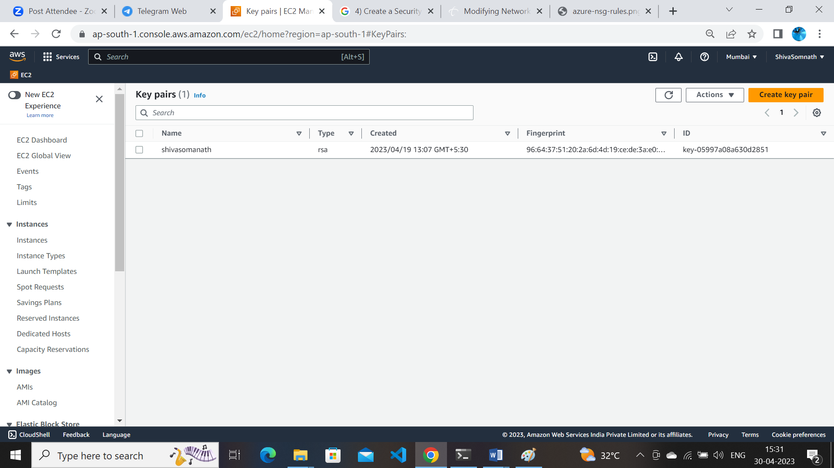

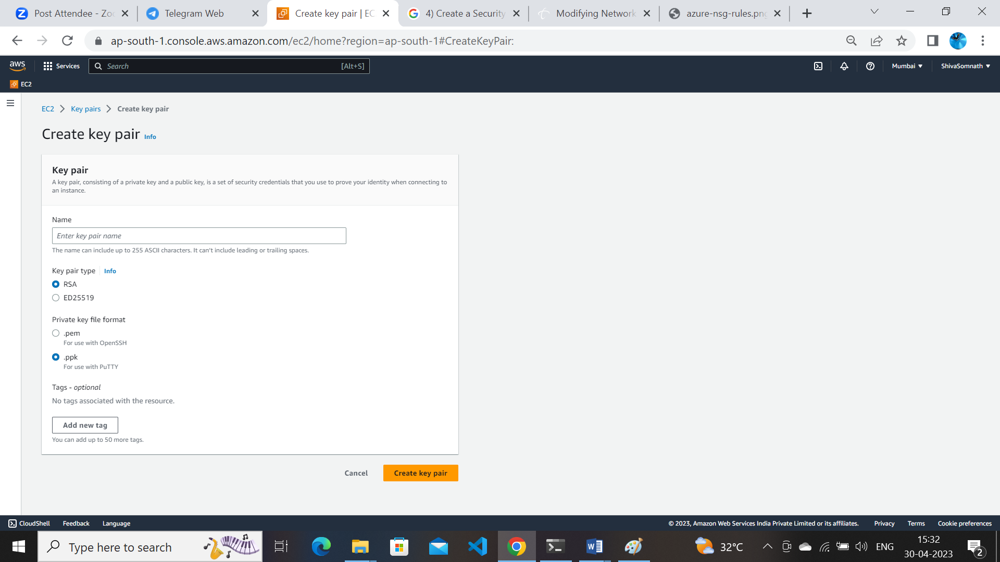

* Give name to keypair
* keypair type RSA /ED25519
* private key file format : .pem/.ppk
* select creat keypair ///keypair created

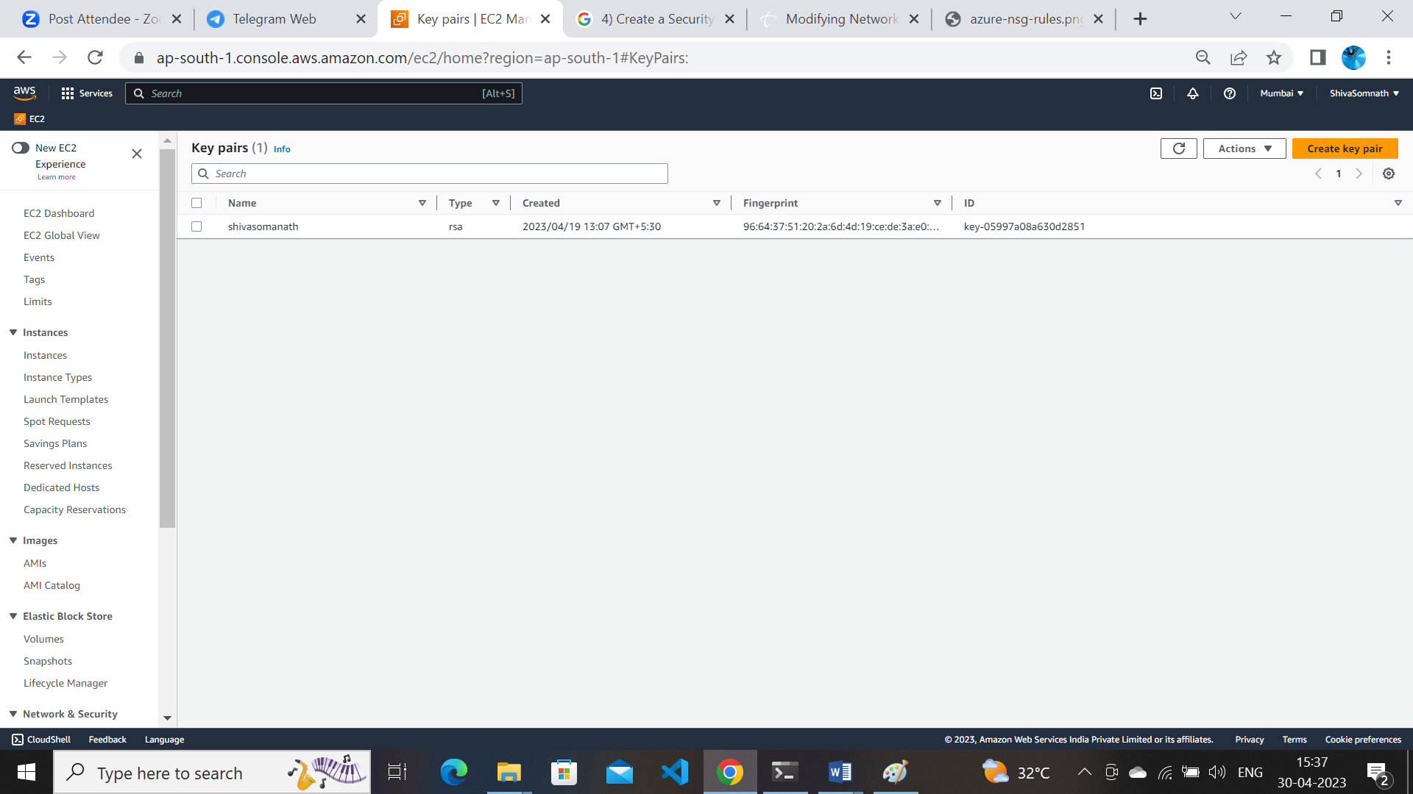

**6)** **Create users using adduser/ useradd /deleteuser/deletegroup/removeuserfrom group and assign passwords and group creation and add the existing user to the group.**

**Adduser**

* login to ec2 machine
* execute command sudo adduser username to add user
* 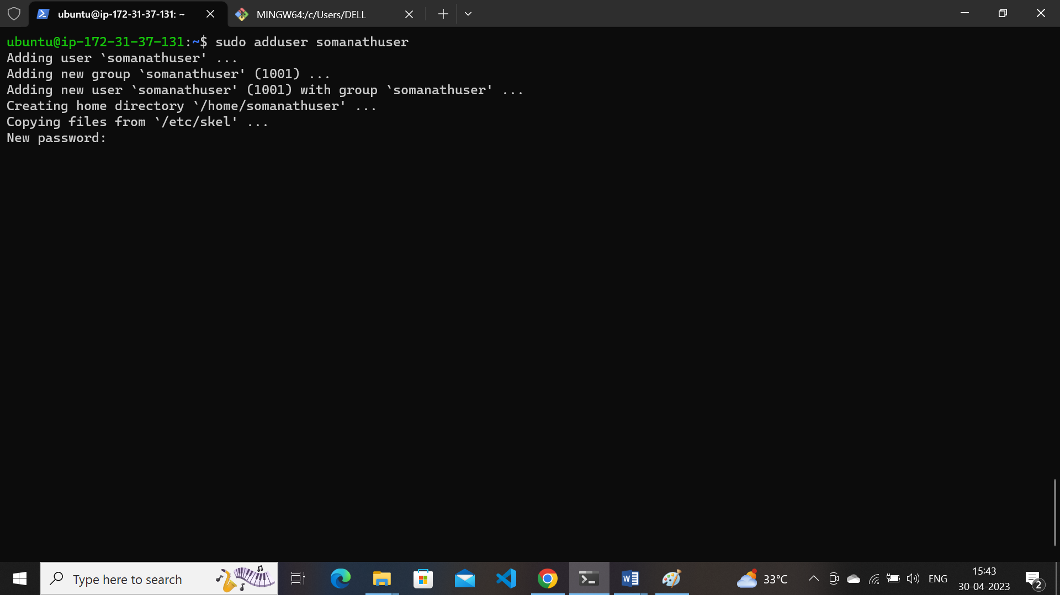
* provide pw to user
* 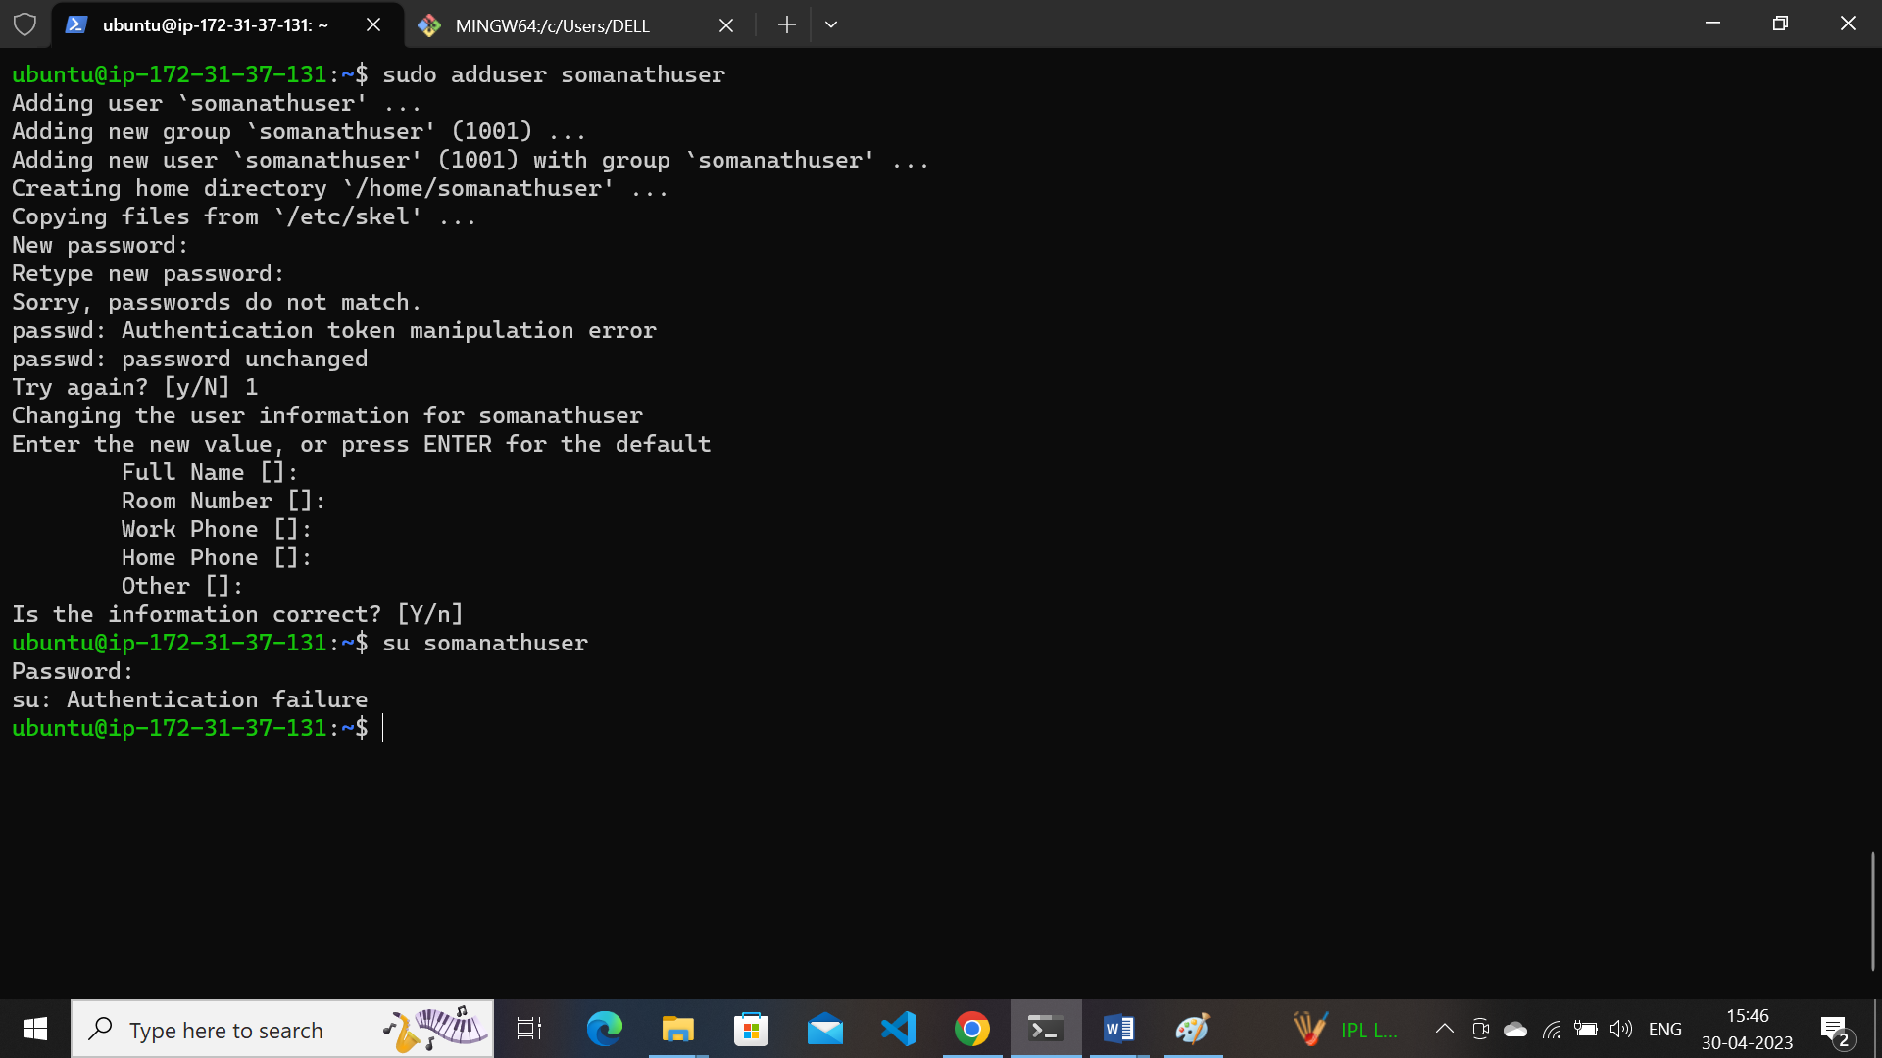
* User added by command adduser
* **USERADD**

Sudo useradd username :command

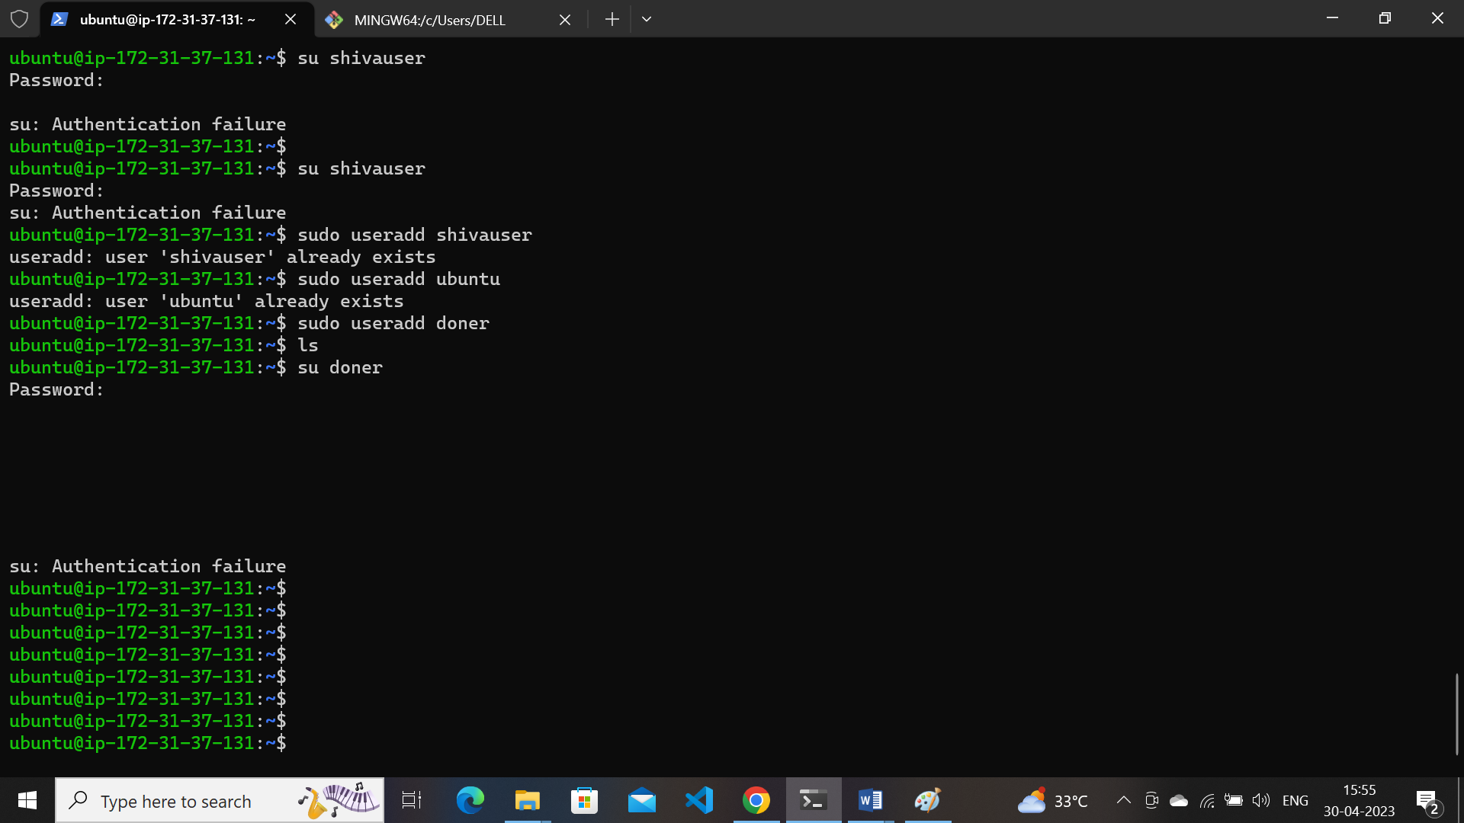

* **Delete user :** sudo userdel username

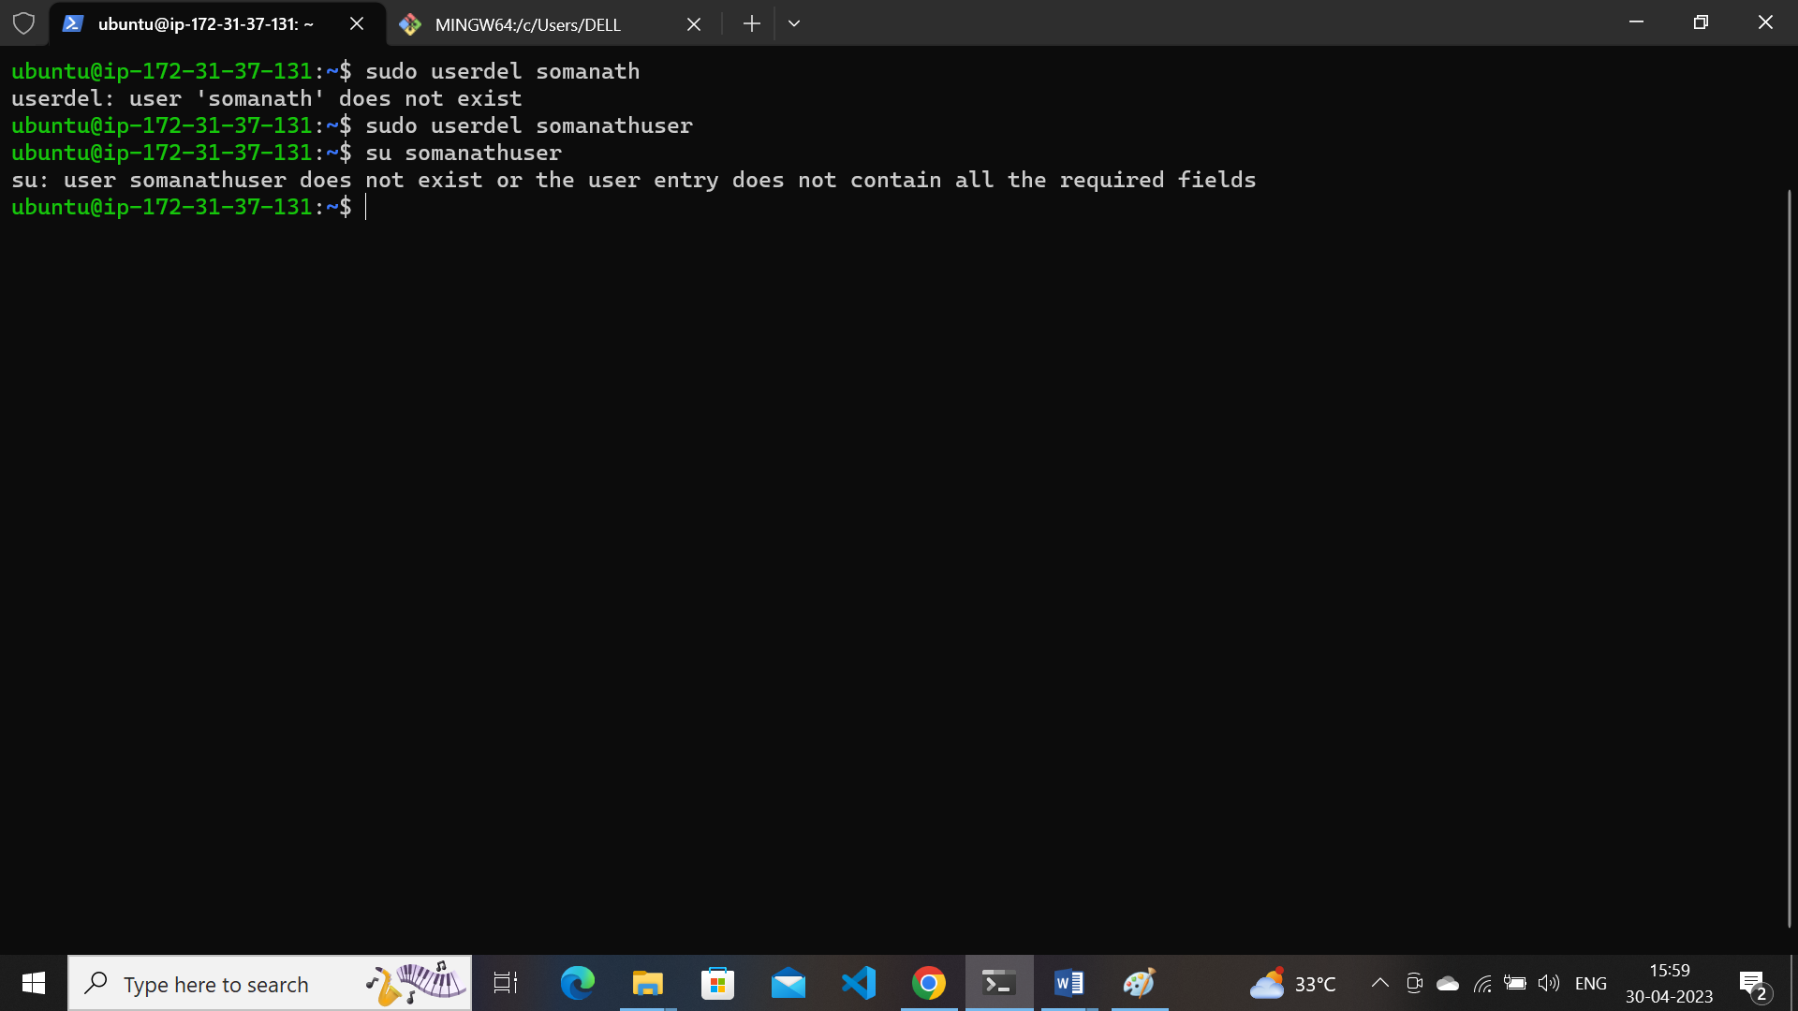

* **Switch user :**  su username
* 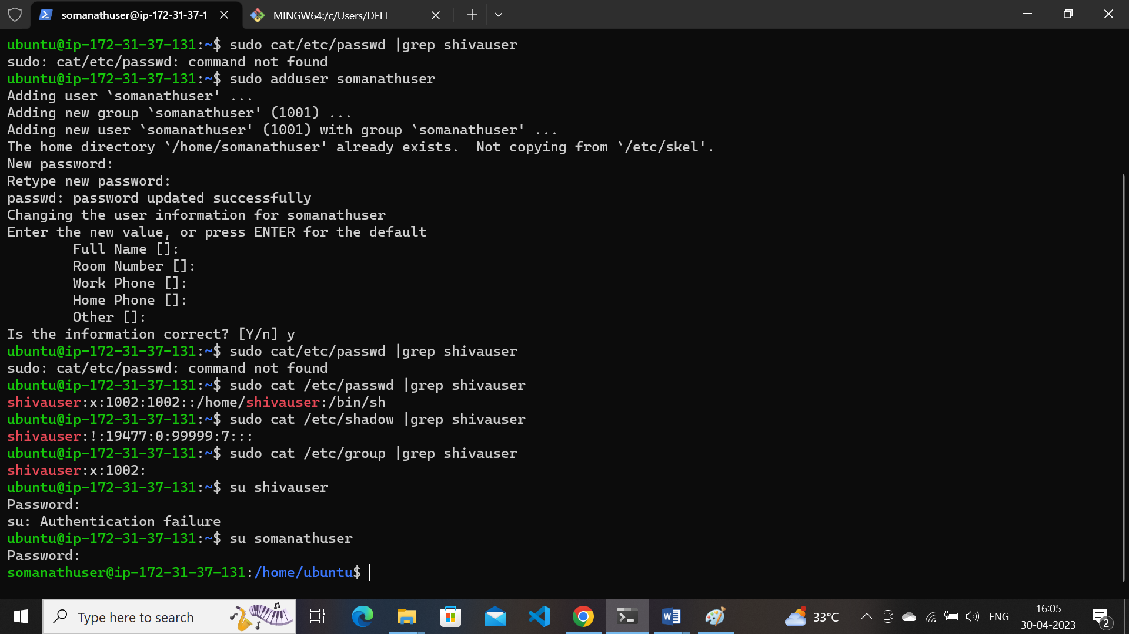

**7) Find the location of users,passwords and groups.**

* 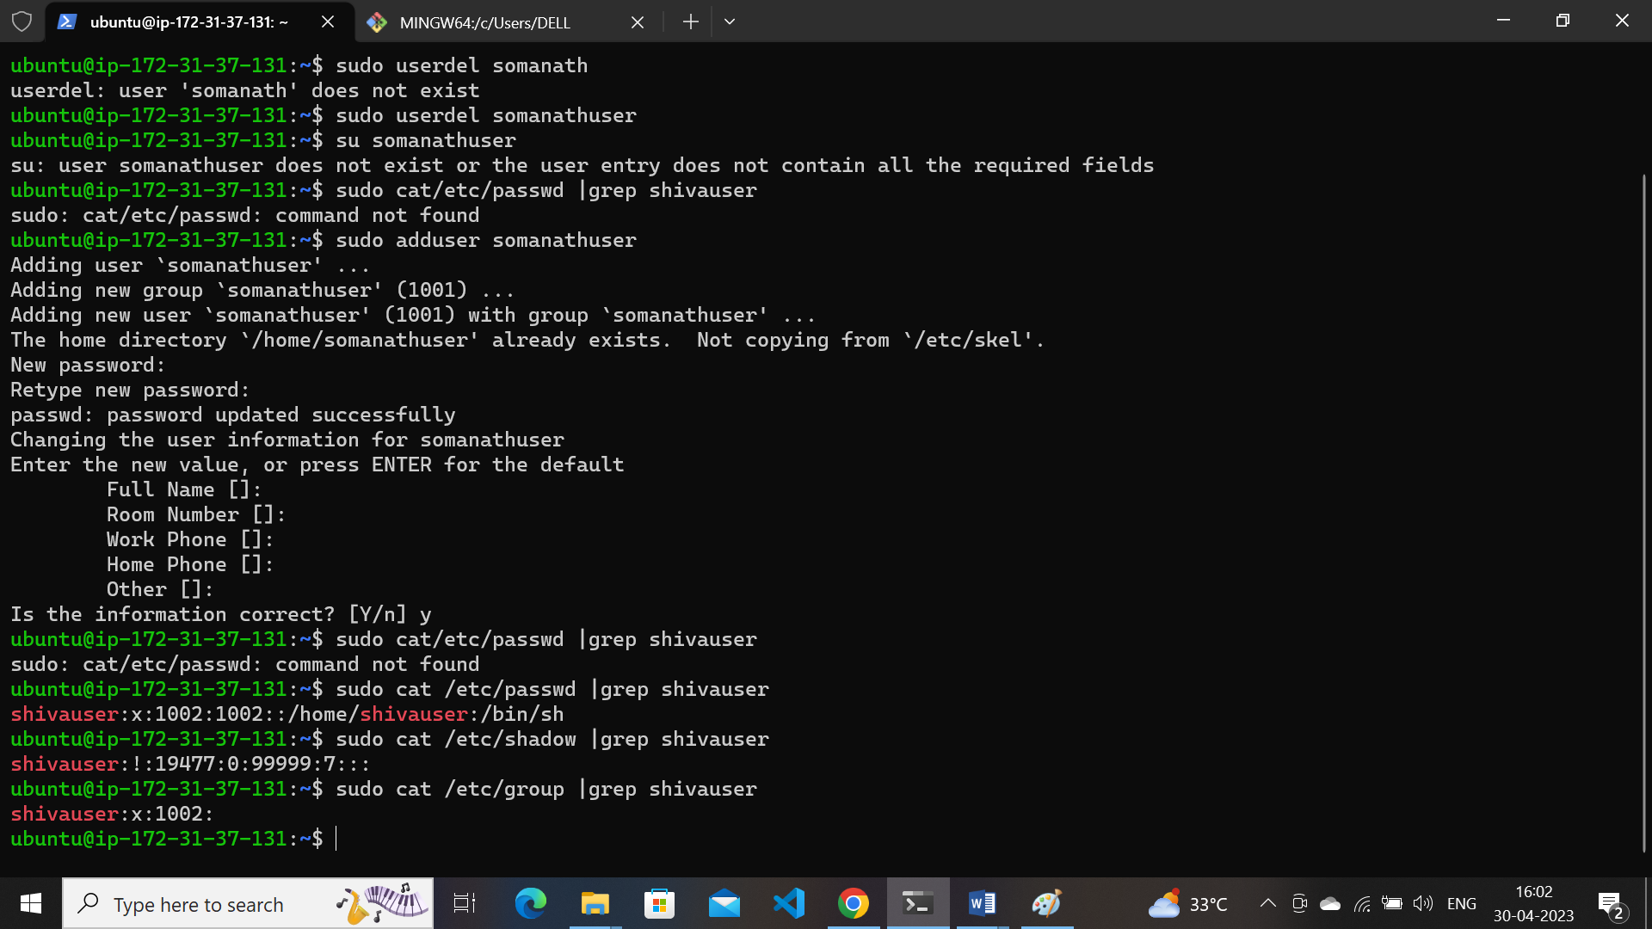

**8)**  **Upload files into a remote repository using SFTP from a local machine.**

* Open windows terminal
* Use command : sftp [ubuntu@52.66.201.214](mailto:ubuntu@52.66.201.214)
* 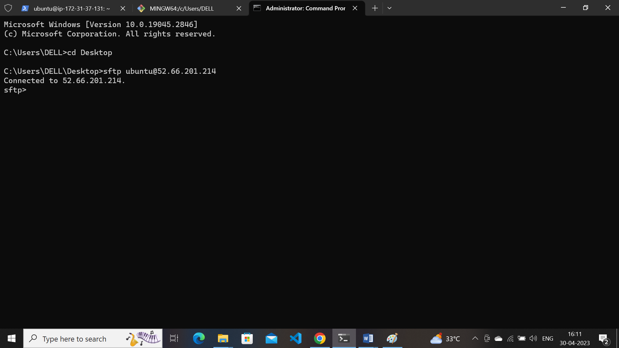
* Put “filename”
* bye
* 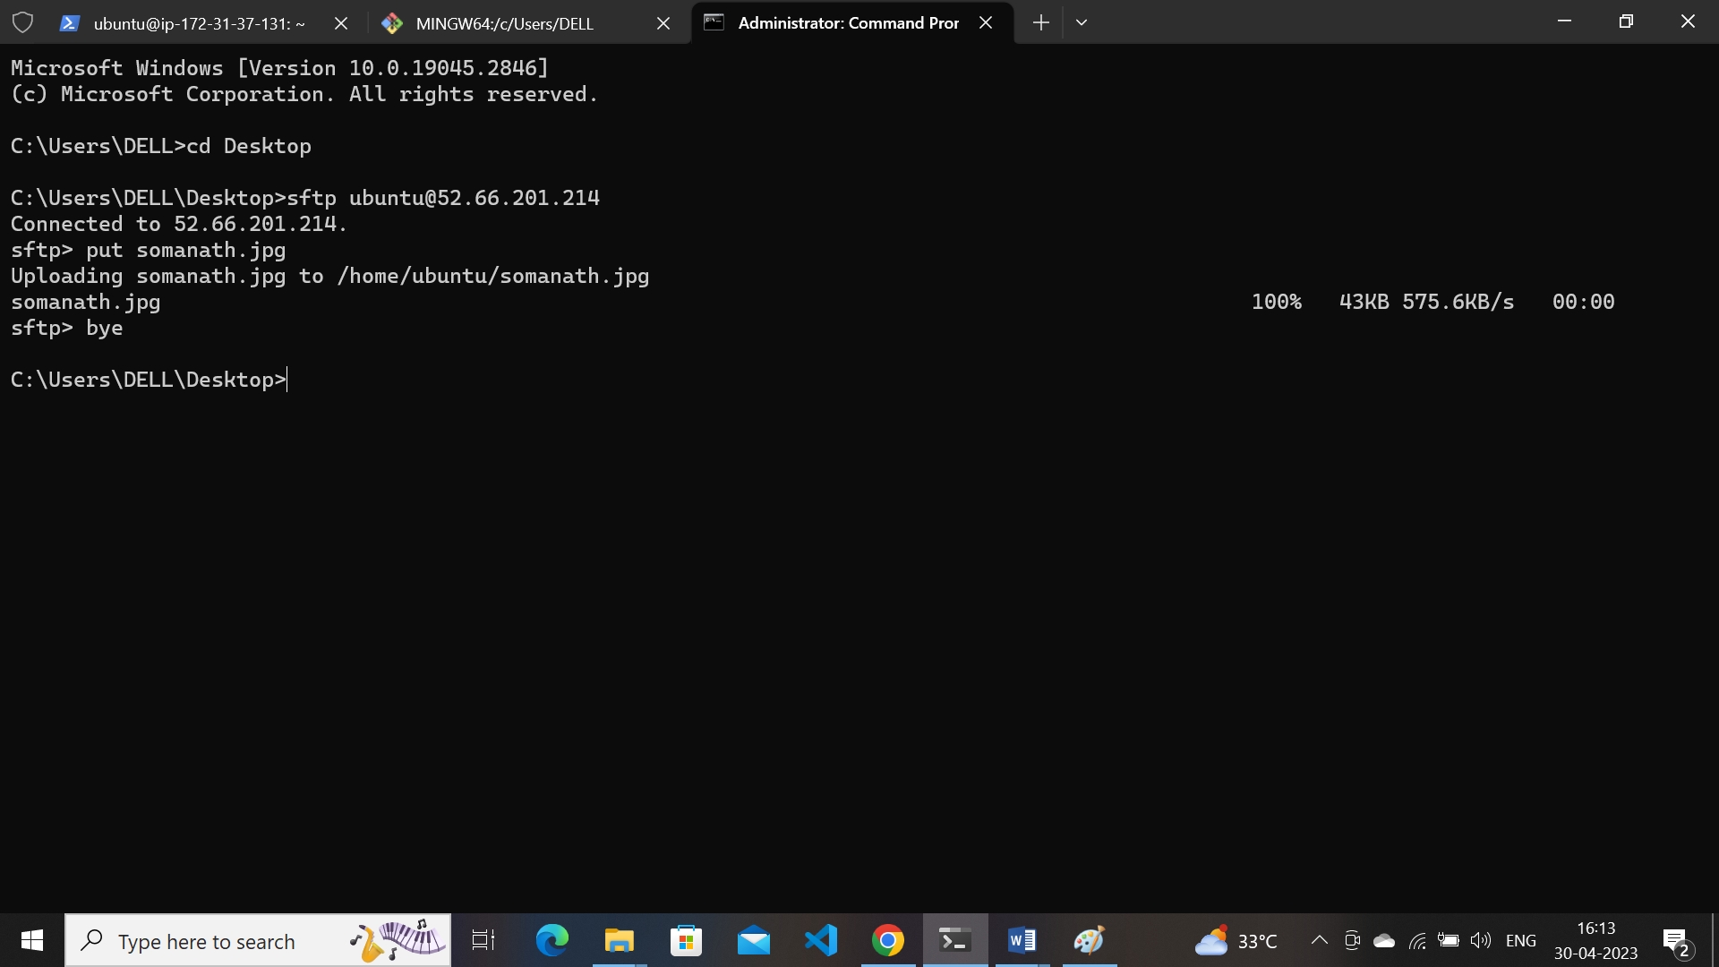
* Now check in ubuntu machine log in ssh server
* File appeared
* 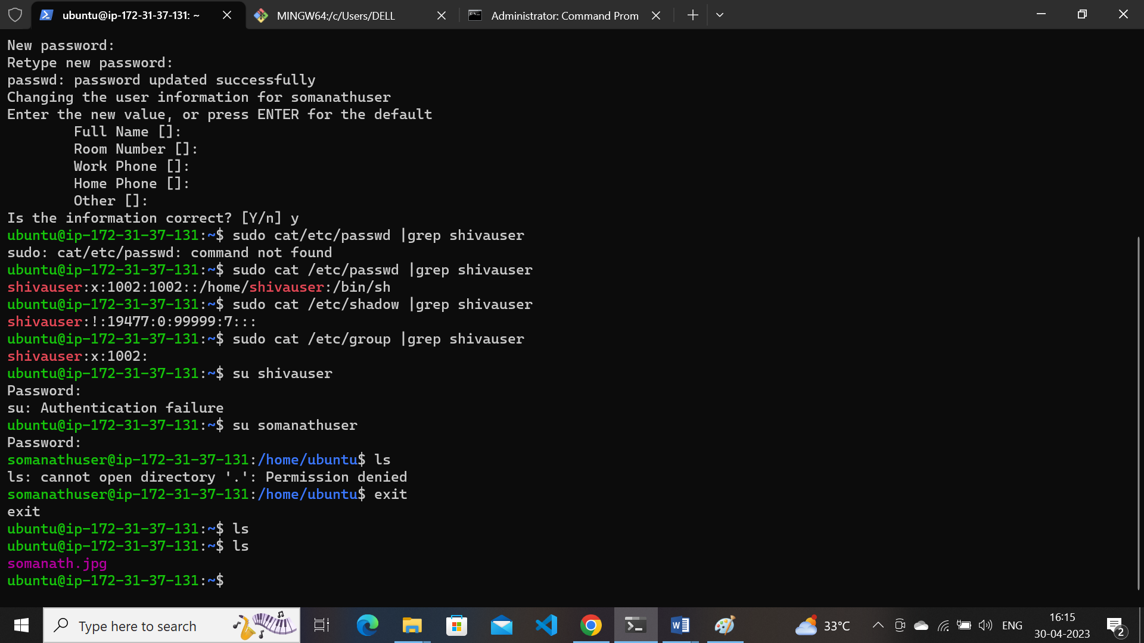

**9). Hands-on file permissions and change ownerships.**

* Log in vm machine create one file and folder by using command :mkdir &touch
* Check file permission in command : ls -l
* Change permission of file by using command :chmod
* 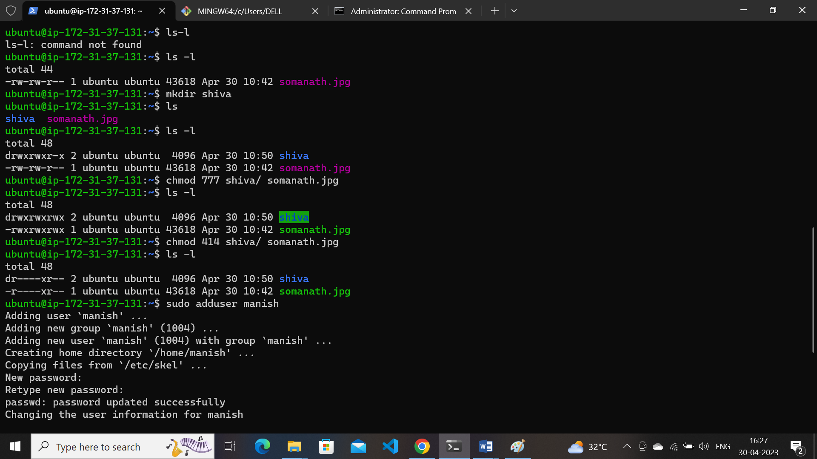
* Adduser by command :sudo adduser username
* Chown permission of file or folder by using command: sudo chown username:username filename
* 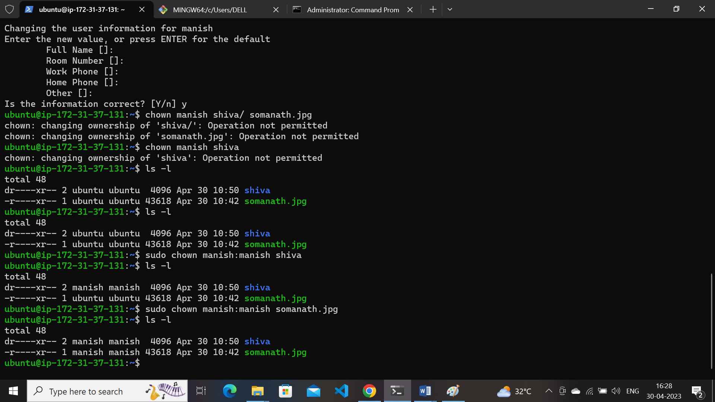

**10) Import key pair/ Ssh keypair concepts on AWS/Azure cloud.**

* go to terminal
* use command use command **ssh-keygen**
* 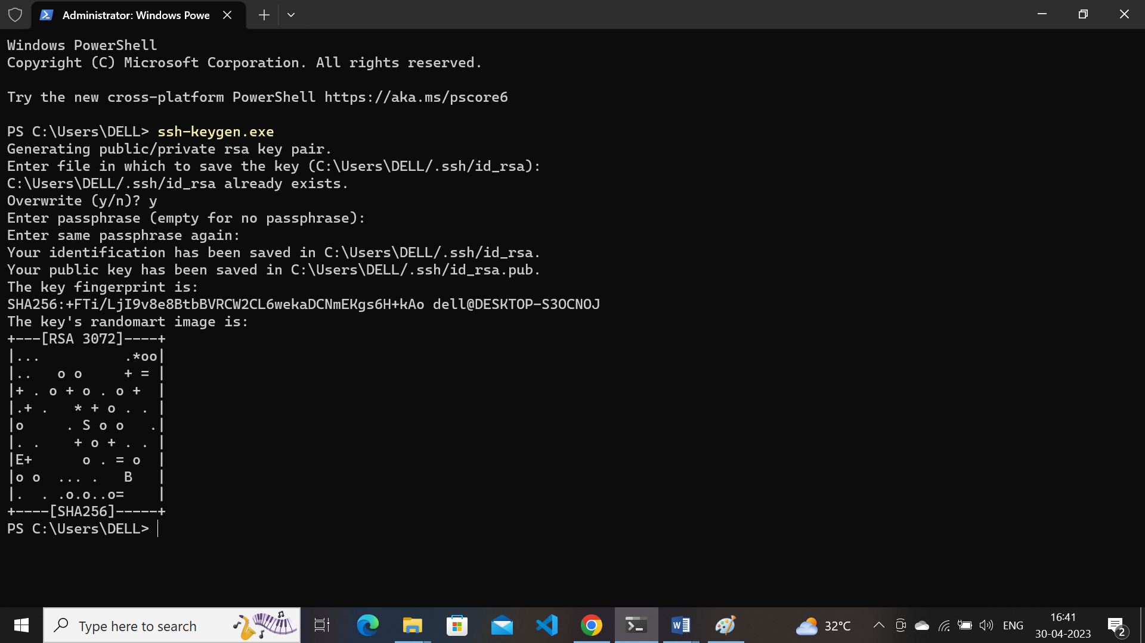
* after key generation open folder name .ssh and find the path id_rsa.pub
* 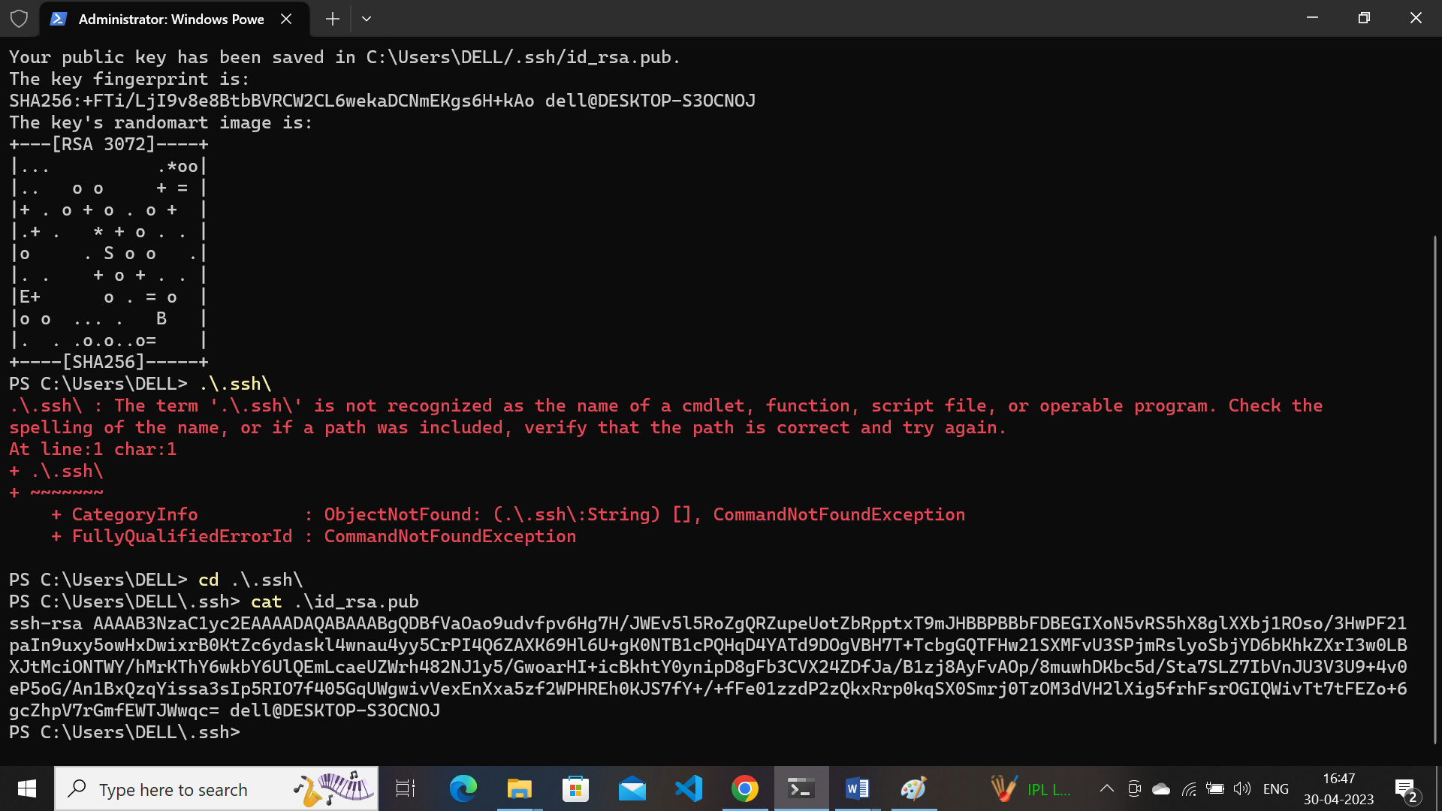
* use the command cat id_rsa.pub copy the path and paste in the aws generate keypair
* select path import keypair
* Paste the which is copied in id_rsa.pub file
* 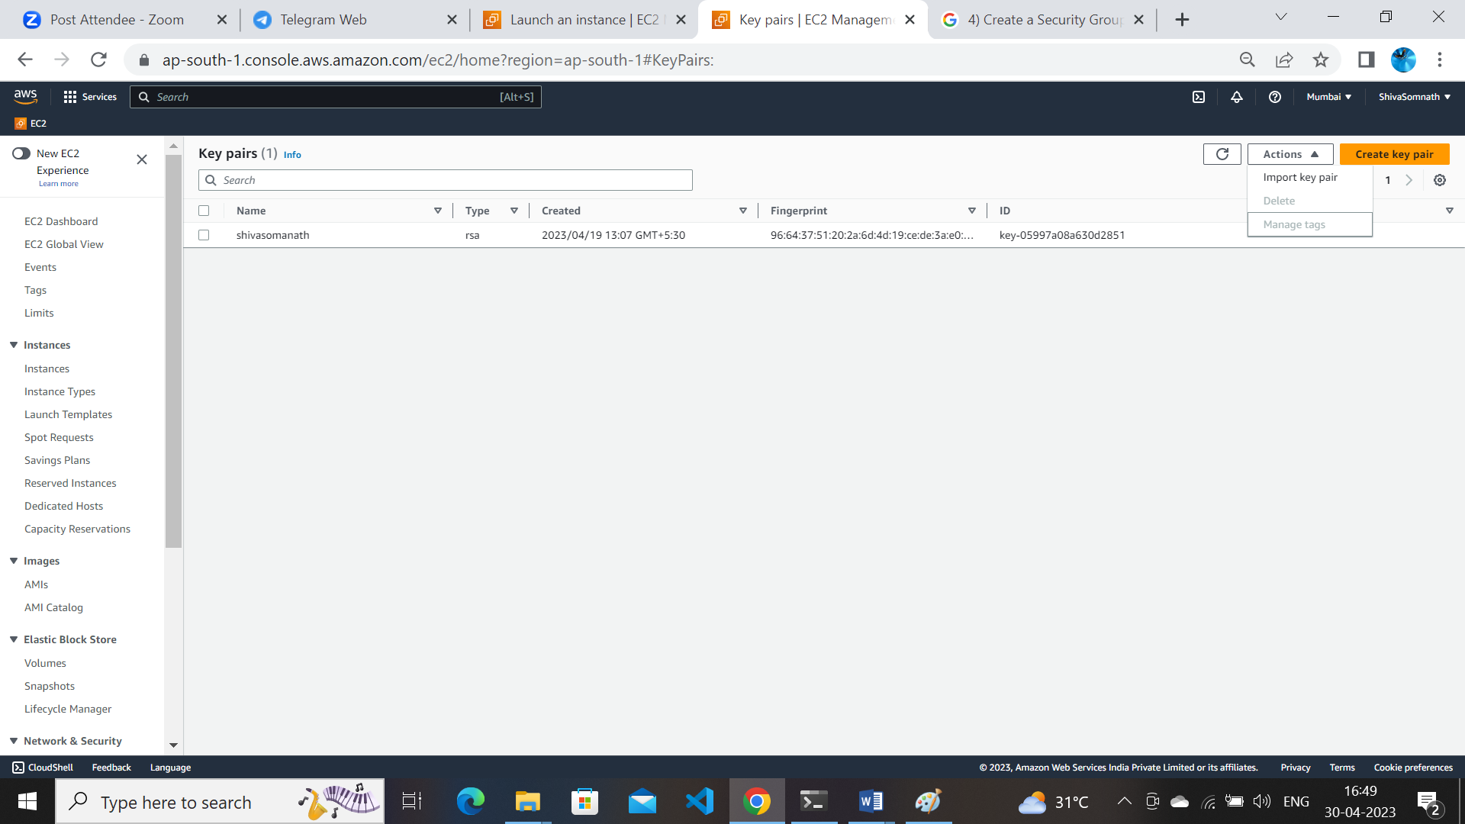
* Gave the name to keypair
* 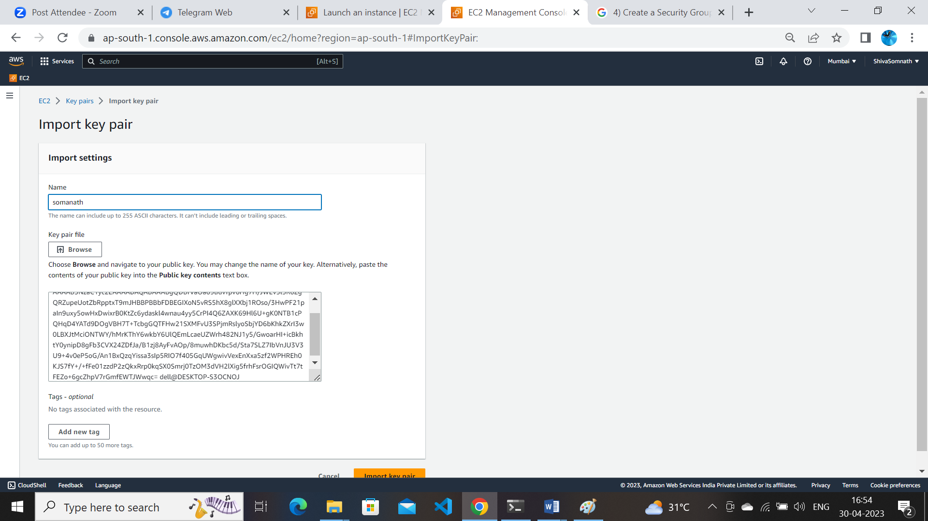
* Keypair generated and sync to aws cloud while using instance
* 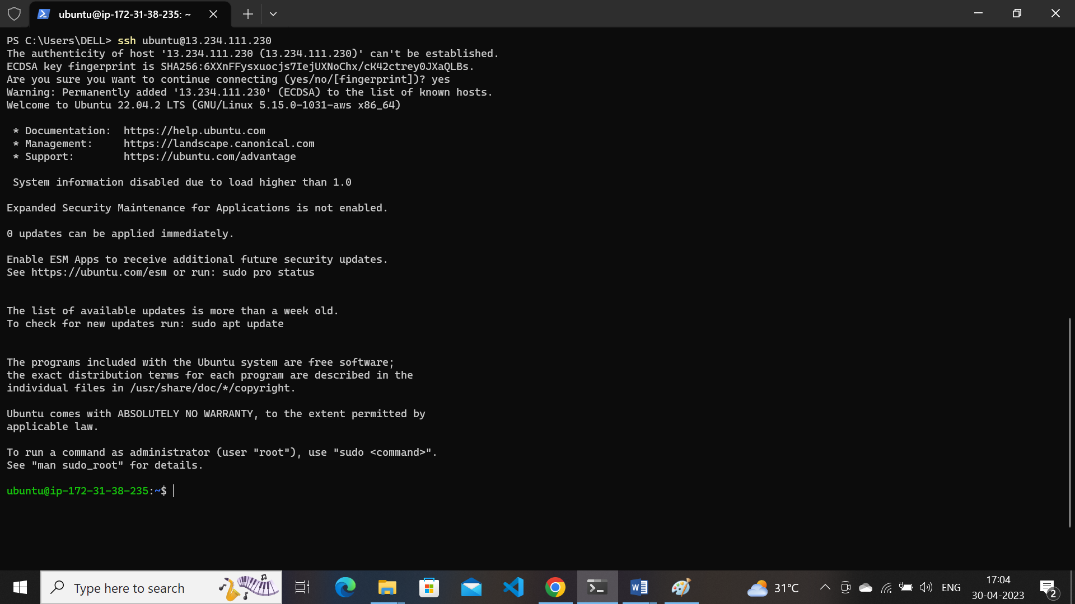

**11). cp and mv rm and rmdir and wc** [**/Head**](tg://bot_command?command=Head)[**/Cut**](tg://bot_command?command=Cut)[**/Sort**](tg://bot_command?command=Sort)[**/Grep**](tg://bot_command?command=Grep)[**/Uniq**](tg://bot_command?command=Uniq) **and process ....etc commands usage**

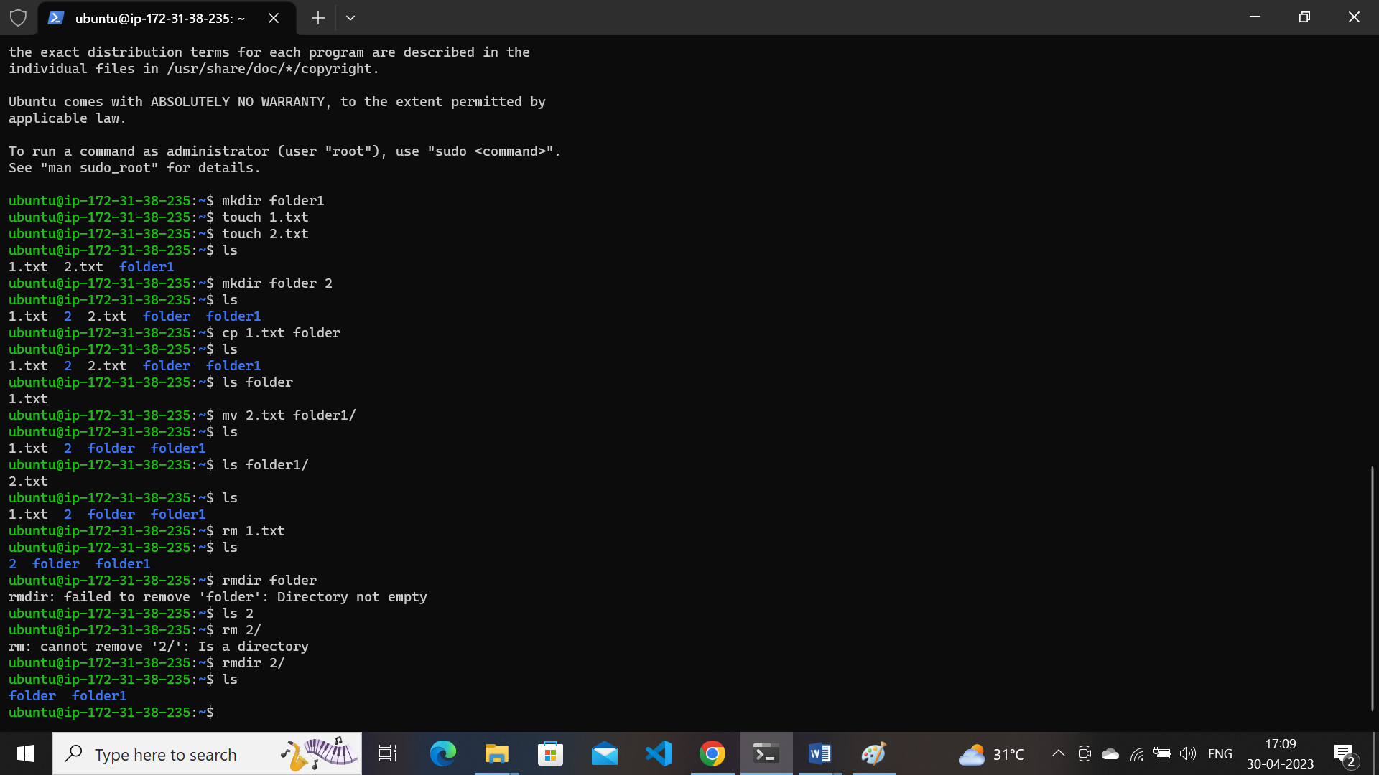

[**/Head**](tg://bot_command?command=Head)[**/Cut**](tg://bot_command?command=Cut)[**/Sort**](tg://bot_command?command=Sort)[**/Grep**](tg://bot_command?command=Grep)[**/Uniq**](tg://bot_command?command=Uniq) understanding the commands –-help command head /cut /sort /grep /uniq by google search

**12). Files and folders navigation and try to work on relative and absolute path usage**.

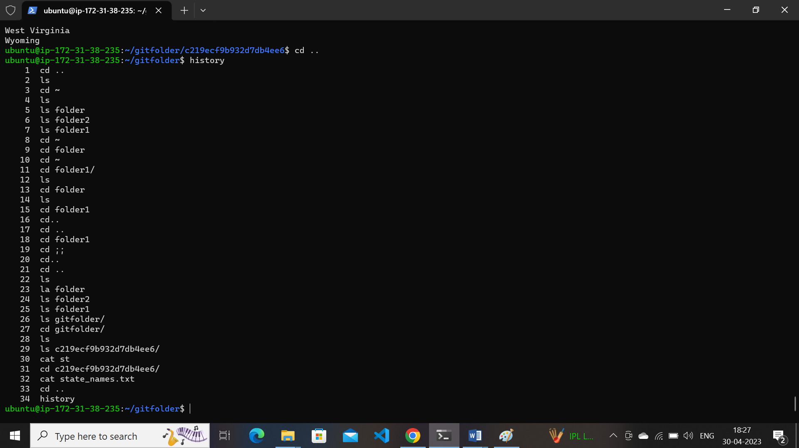

Navigation keys cd .. /cd ~/ls /cat / history several commands understanding navigation keys

**13). vi editor usage and** [**openvim.com**](https://openvim.com/) **practice.**

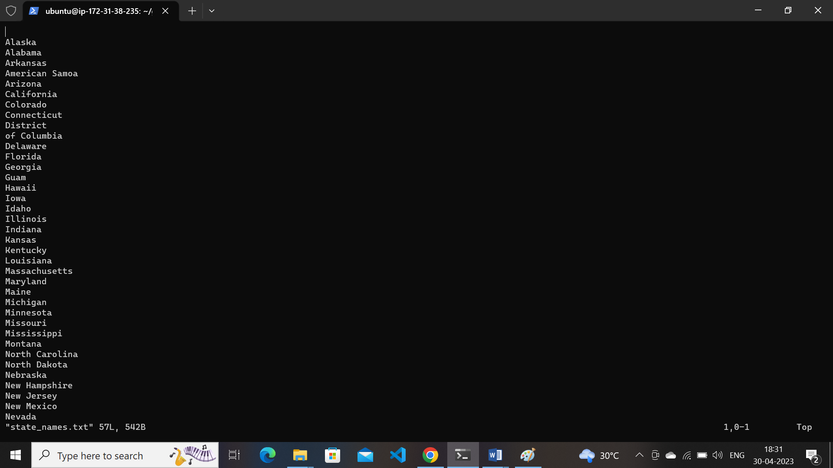

* Understanding vi editor commands modes insert mode / normal mode etc..
* Commands q /q! /wq /wq!

**14). Establish connection between 2 remote machines using ssh manual procedure**

* Create two ec2 machines with two different keypairs
* Log in 2 instances two different like powershell //git
* Create name for those host name cmd
* sudo hostnamectl set-hostname remote2
* exit and re login both machines then name login visible
* REMOTE1 REMOTE 2
* Ls ls
* Pwd pwd
* Cd.ssh cd.ssh
* Authorisedkeys ssh -keygen
* Ssh key gen ls
* Ls authorised keys
* Cat id_rsa pub sudo vi authorised keys
* Copy the path paste here

Enter different machine SSH ubuntu@ip

* remote mission 2

NOW CHECK the rm 1 to ip ping

Login 2 machines

* 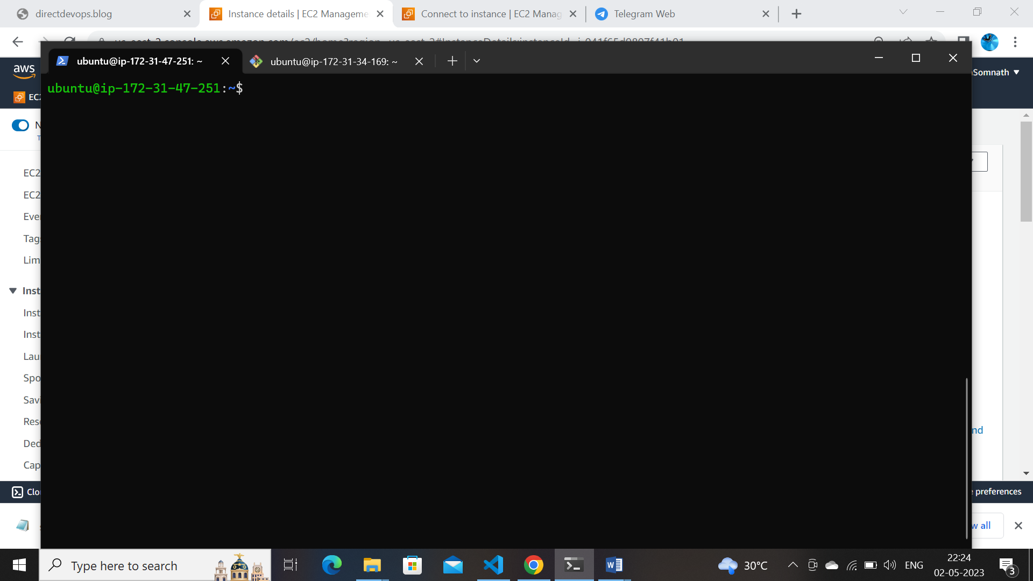
* 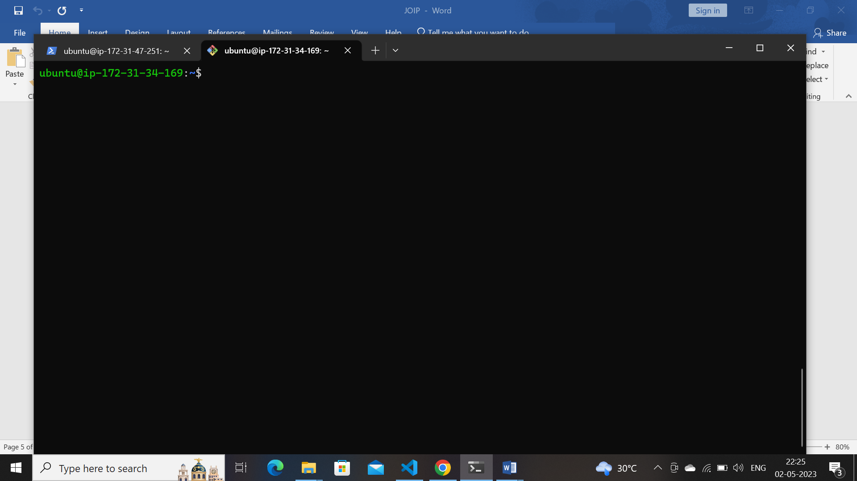
* Set different hostnames 2 machines for easily understanding purpose command :sudo hostnamectl set-hostname “name”
* exit and re login both machines then name login visible
* 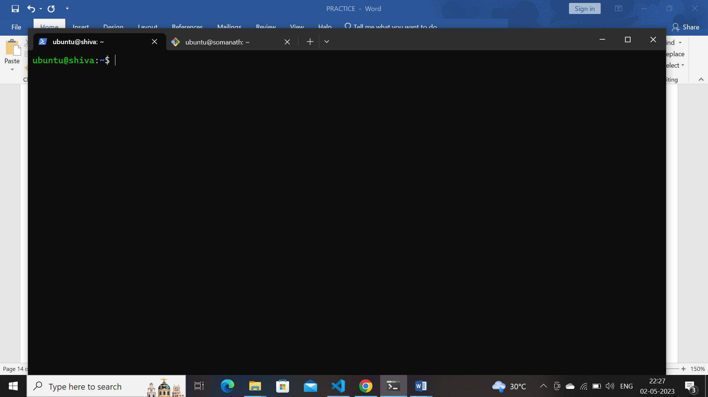
* 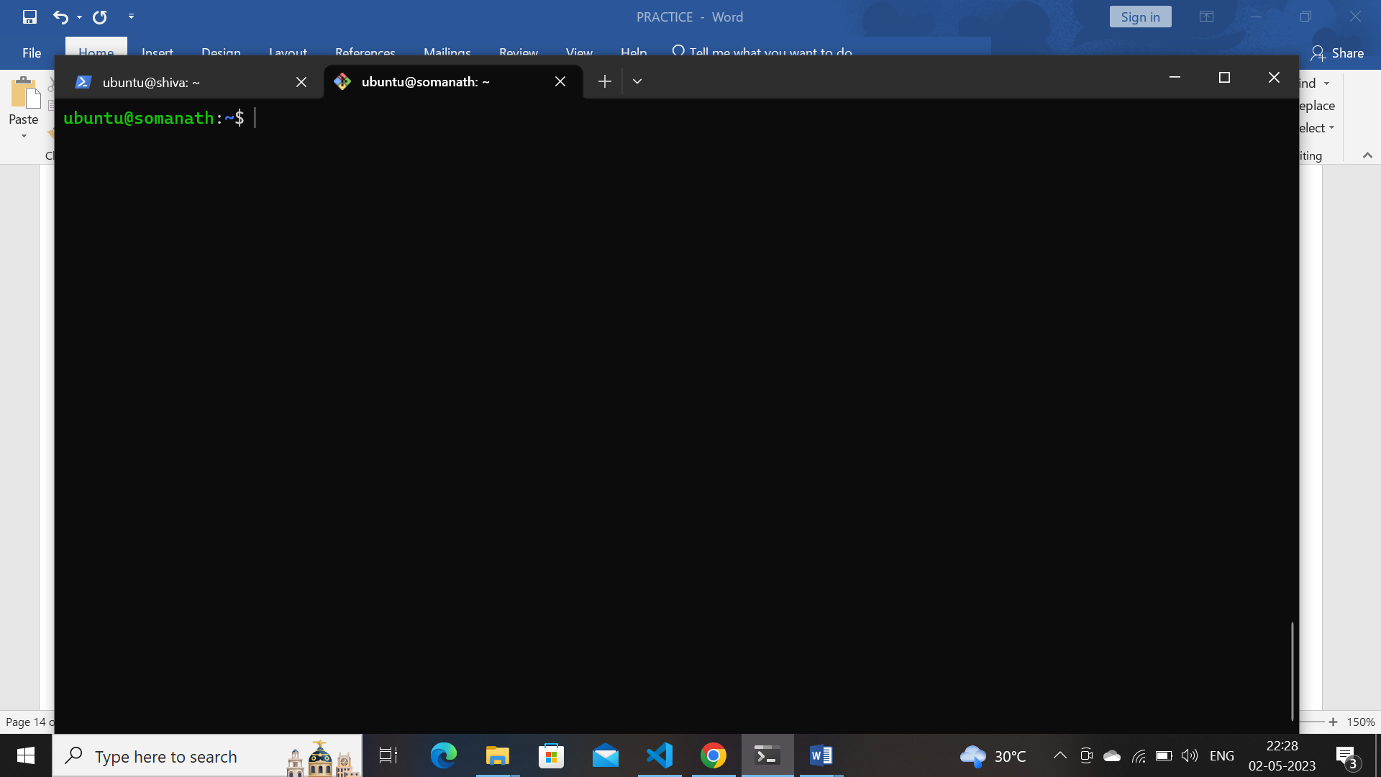
* Log in 1st machine as mentioned command use copy the id_rsa.pub
* 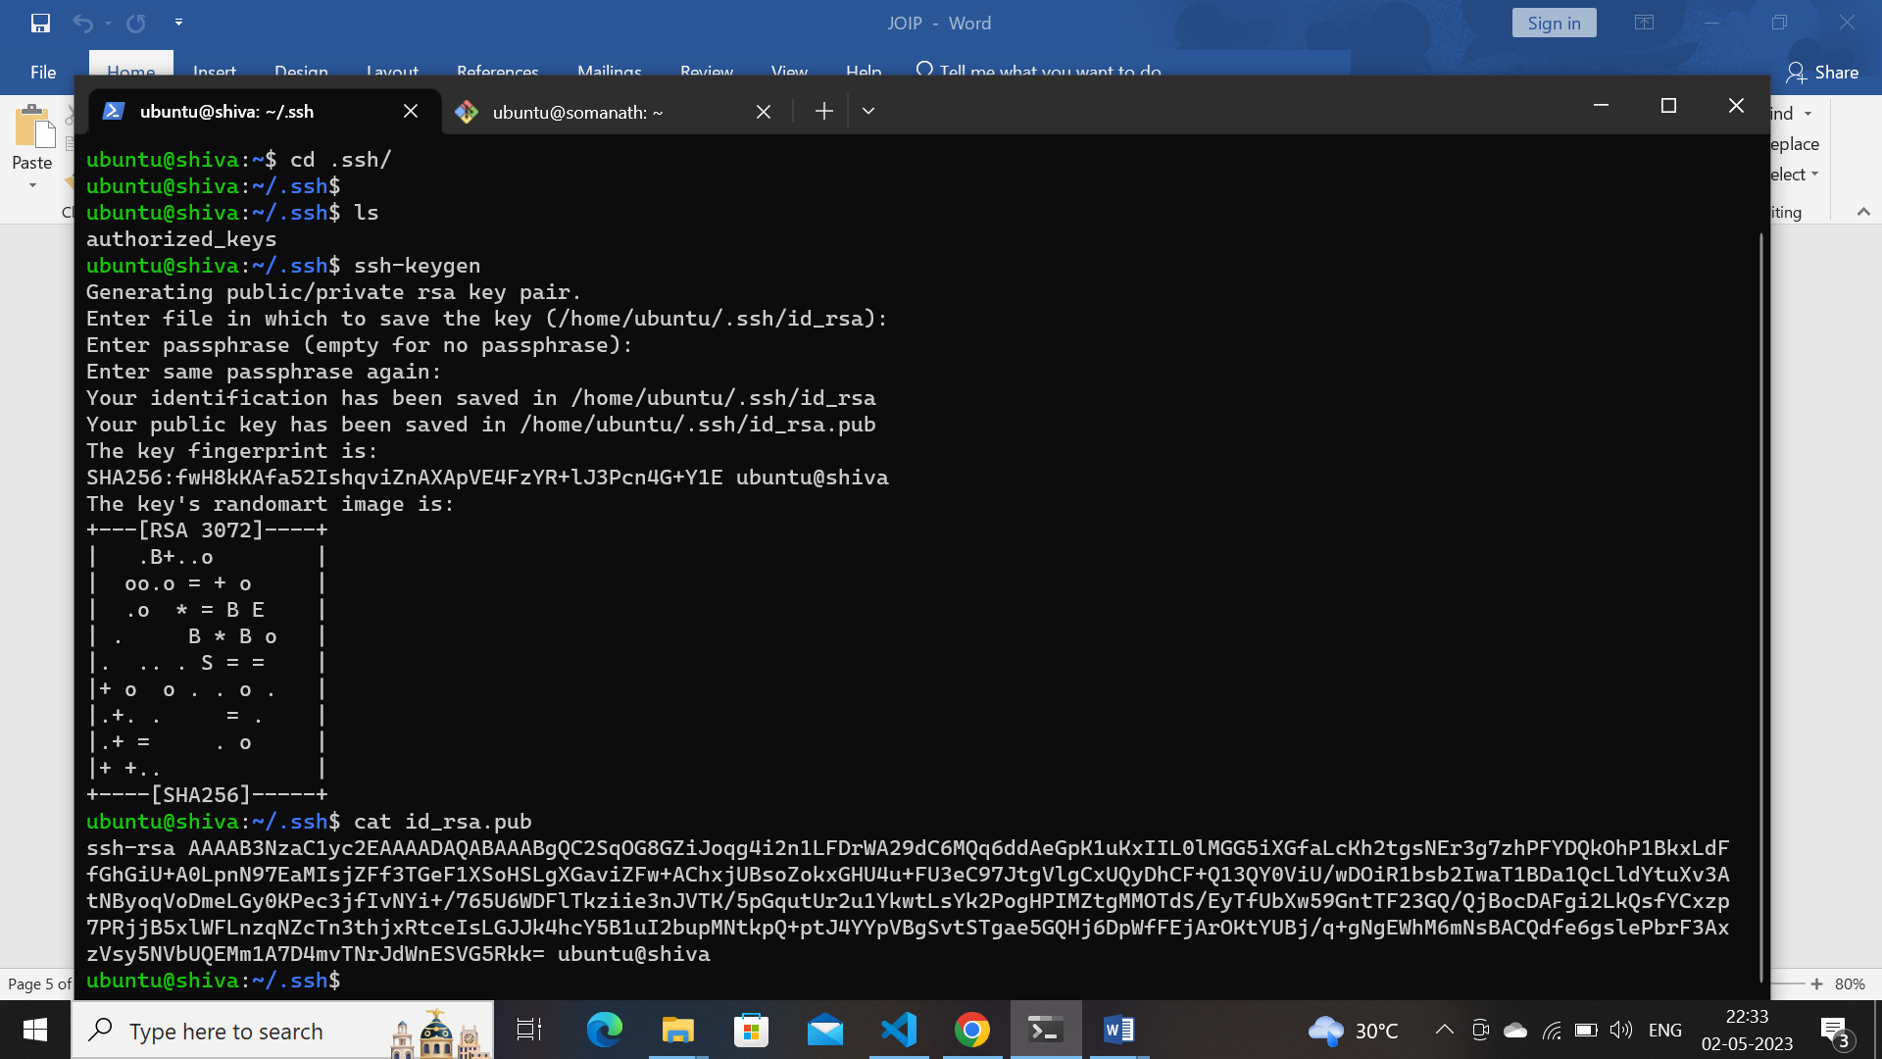

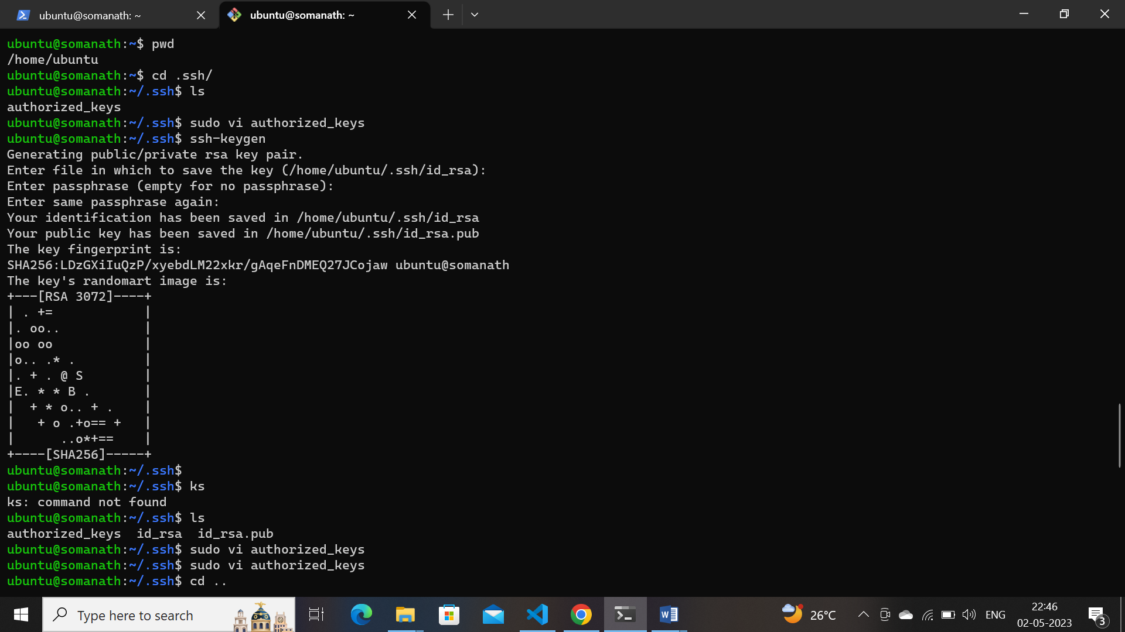

Paste in vi editor in authorizedkeys of second machine

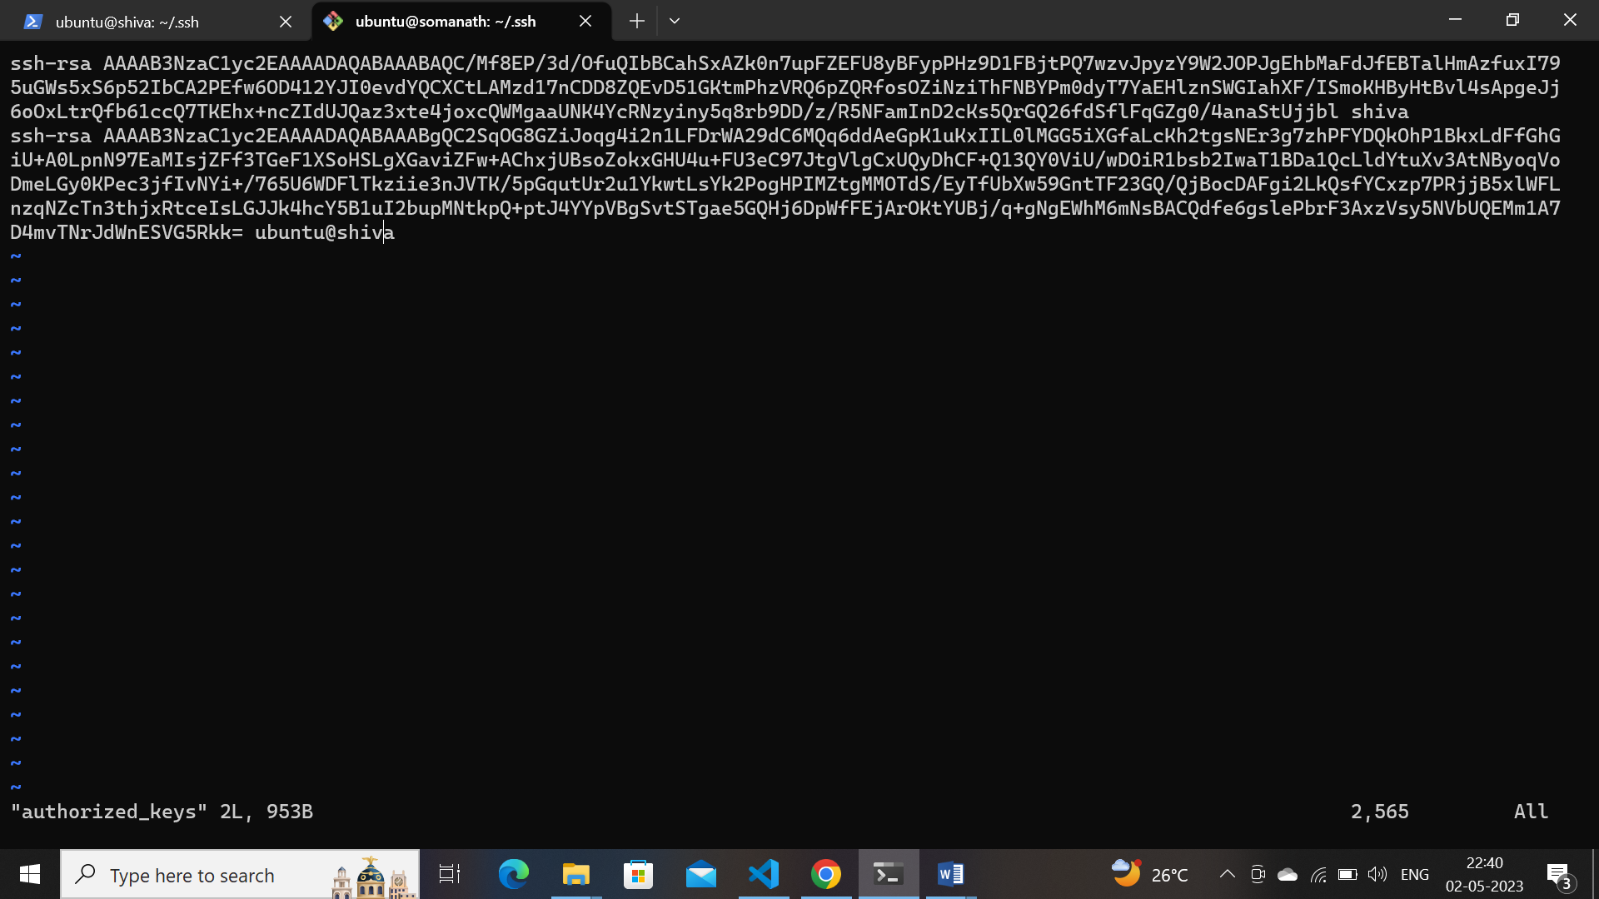

Enter different machine SSH ubuntu@ip we are observed connection b/w both machines

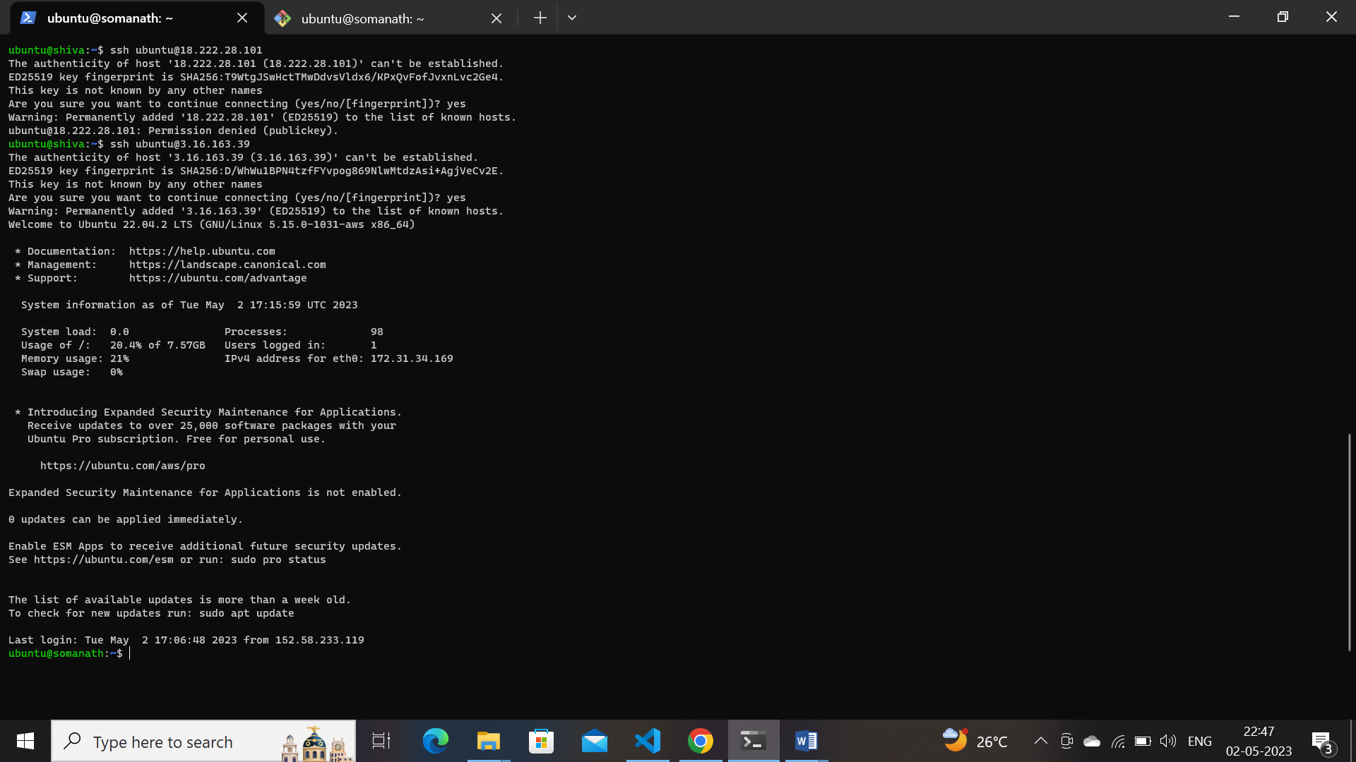

**15. Try to create a shell file with some commands and execute/run it.**

* Create a file in vi editor using #! bin/bash or #! bin/sh command
* Example1:creating folder and files and echo command ,date execution by shell file
* #!/bin/sh
* echo hello there
* mkdir f1 f2 f3 f4
* touch 1.txt 2.txt 3.txt 4.txt
* date
* ***vi editor script***
* 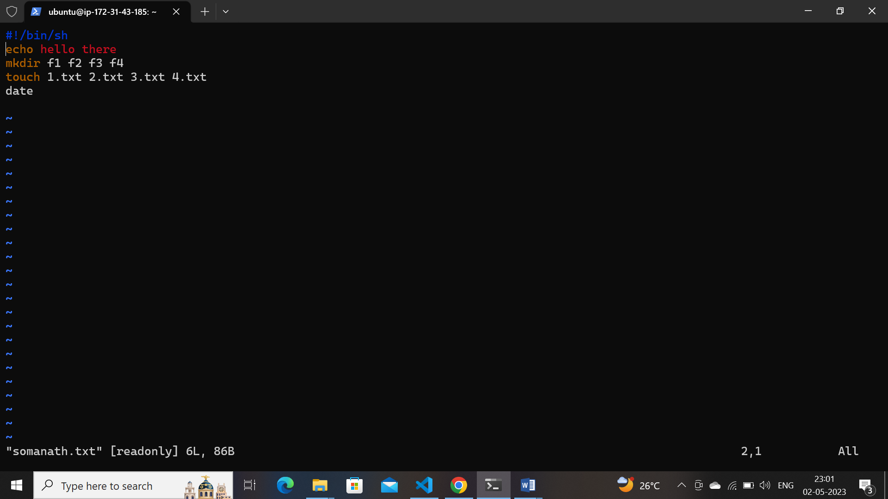
* **Result… as per shell files and folders created**
* 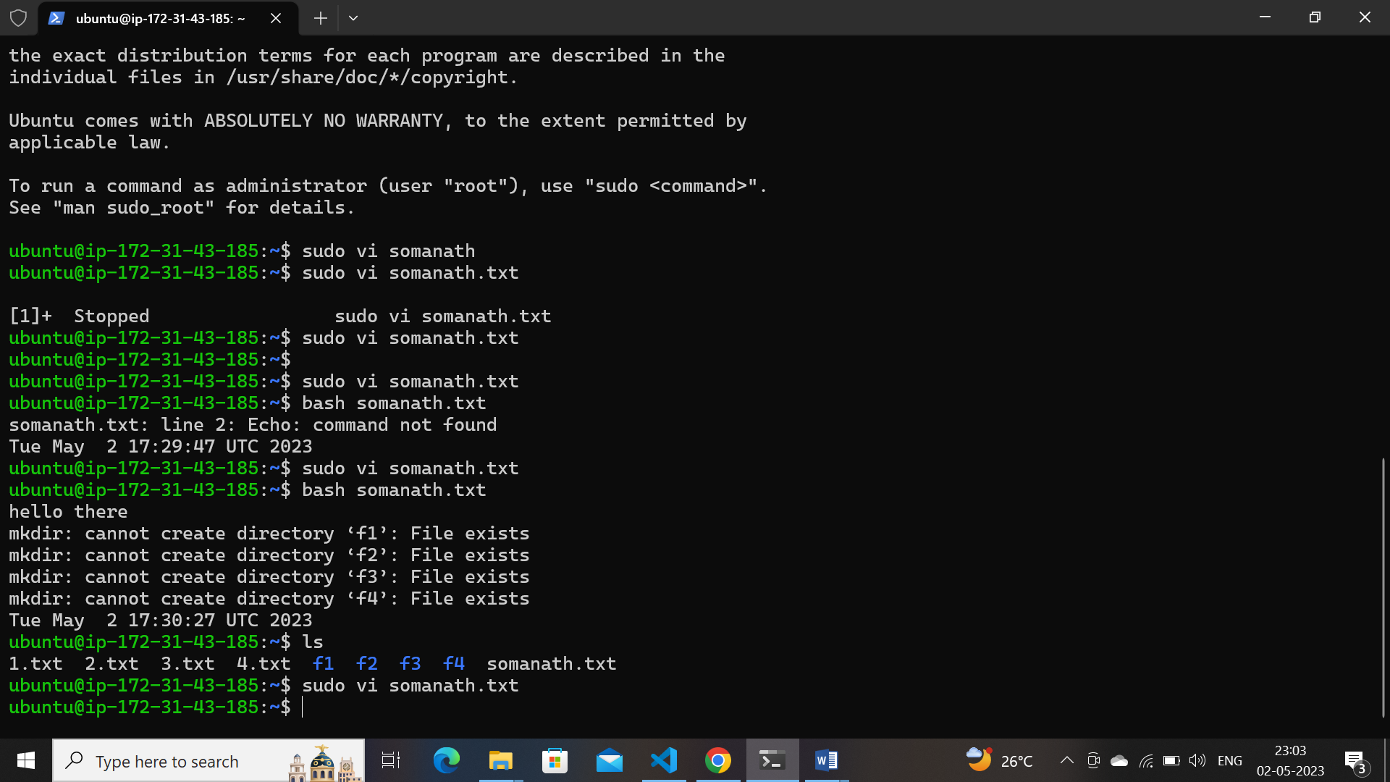
* **Example2**:by execution shell install apache in vm
* #!/bin/bash
* sudo apt update
* sudo apt install apache2 -y
* sudo systemctl status apache2
* **Shell file commands**  for install apache2
* 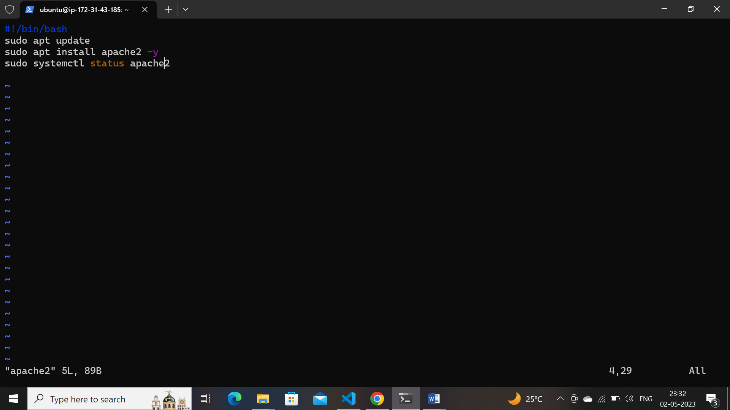
* **After using command :bash**  installed
* 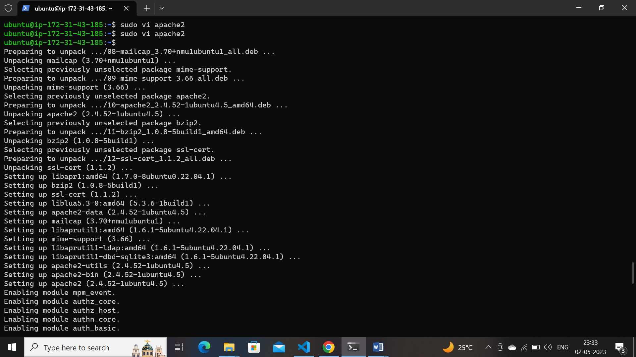

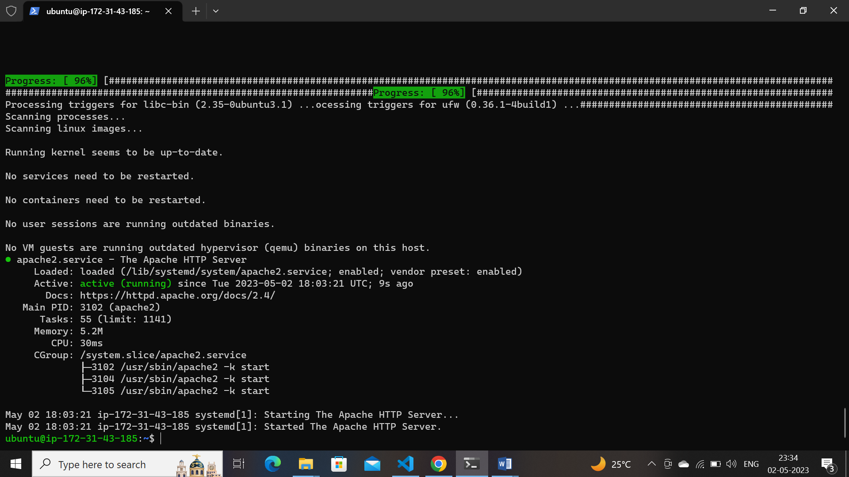

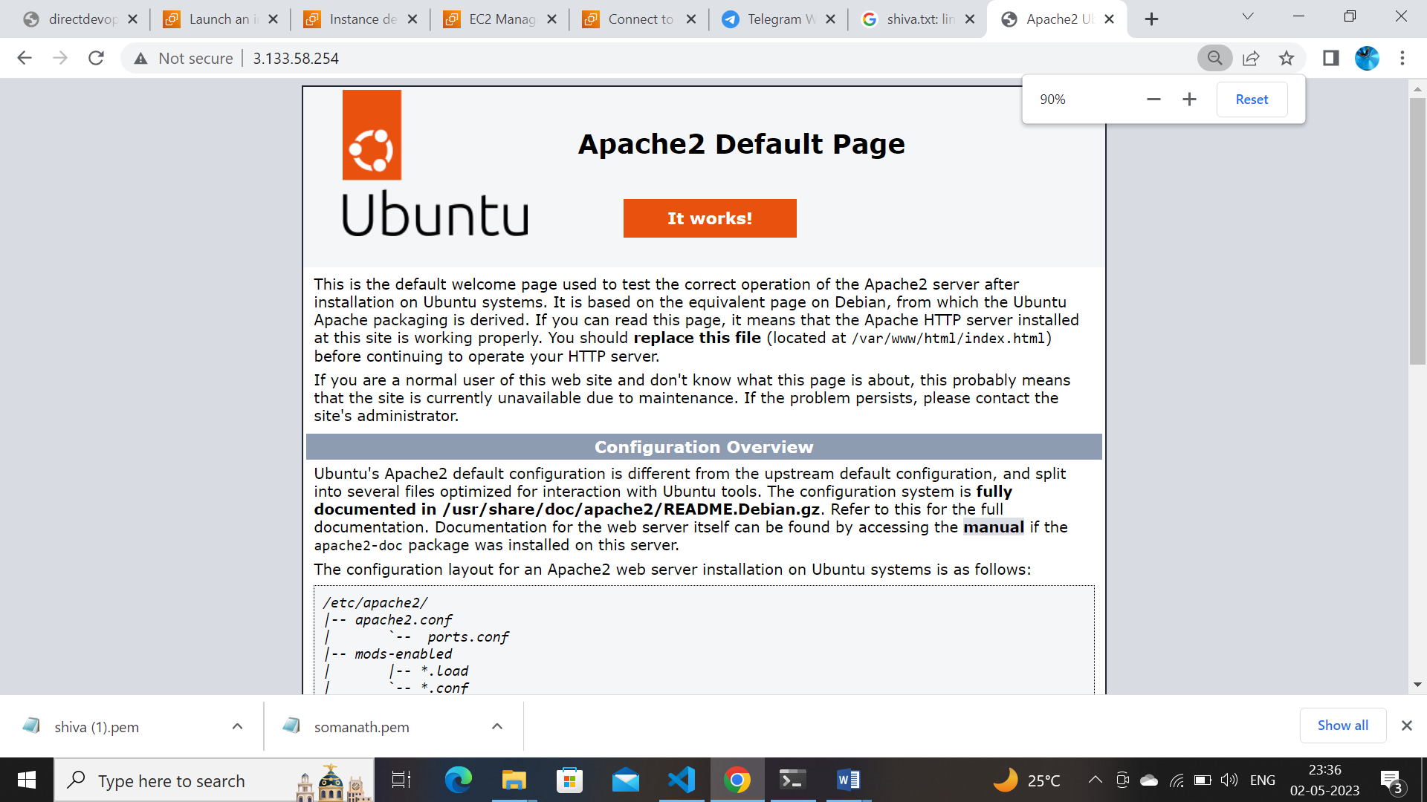

**16. Create 100 files using a single command.**

**.** **touch somanath{1..100}.txt**

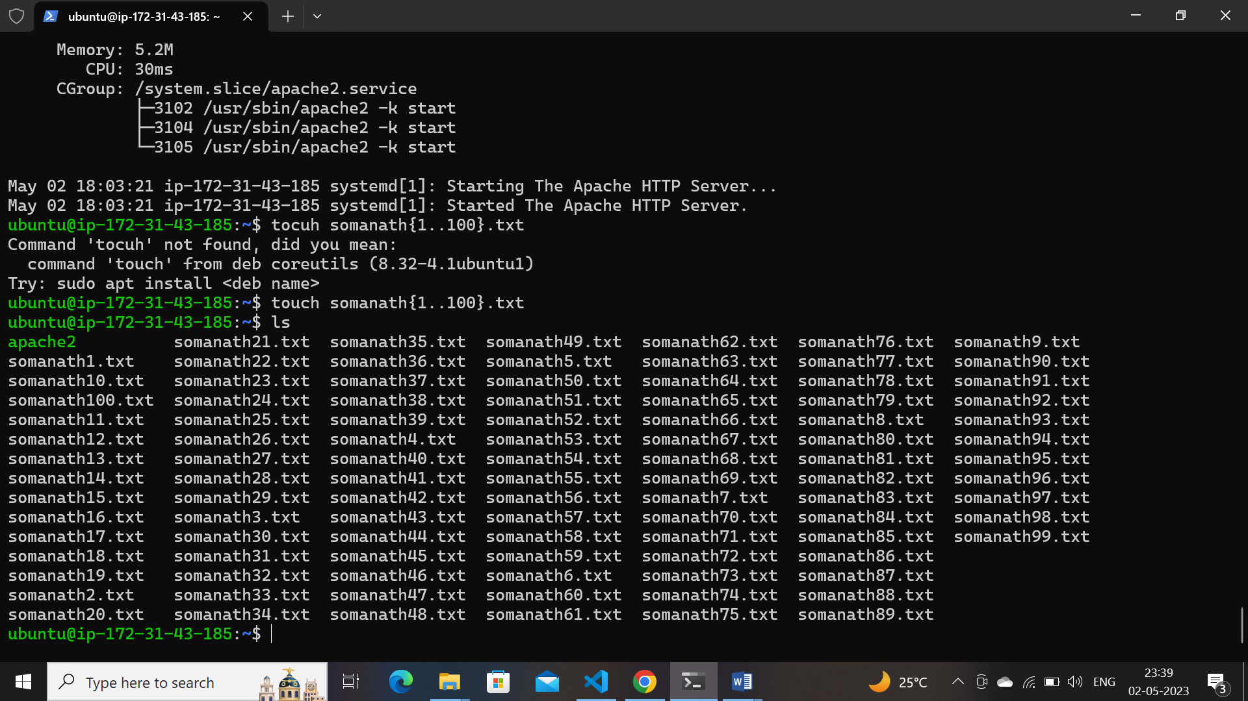

**17). Create a VM/EC2 and install apache2/Tomcat web server on ubuntu/CentOS and access it through the internet**

**Apache2..in ubuntu**